WORKBOOK ANSWERS

OCR AS Economics Unit F582

The National and International Economy
This Answers book provides suggestions for some of the possible answers that might be given for the questions asked in the workbook. They are not exhaustive and other answers may be acceptable, but they are intended as a guide to give teachers and students feedback. The student responses (green text) for the longer essay-style questions are intended to give some idea about how the exam questions might be answered. The examiner comments (blue text) have been added to give you some sense of what is rewarded in the exam and which areas can be developed. Again, these are not the only ways to answer such questions but they can be treated as one way of approaching questions of these types.
Topic 1
Aggregate demand and aggregate supply and their interaction
The components of, and influences upon, aggregate demand
1 Aggregate demand is the total demand or expenditure within an economy over a given period of time. It refers to the total planned expenditure on goods and services from all elements in an economy.
2 Aggregate demand is made up of four components:
- consumer spending, i.e. the total expenditure by all consumers/households in an economy
- investment by firms in such things as plant, machinery and equipment
- spending by the government
- the net effect of international trade, i.e. the value of exports minus the value of imports
3 Consumption can be influenced by a number of factors, such as a change in the savings ratio. If less money is saved, more can be spent. An advertising campaign could also influence consumption, causing AD to shift to the right. An increase in consumer confidence could also have a positive effect.
Investment decisions by firms can be affected by a number of factors. For example, a fall in interest rates is likely to encourage firms to invest, as would a rise in business confidence, moving AD to the right.
Government decisions about expenditure will be influenced by fiscal policy. For example, if revenue is expected to increase, this will provide the funds for an increase in expenditure, so this will cause AD to shift to the right.
Finally, there could be a net increase in trade due to a fall in the exchange rate, making exports cheaper and imports dearer, assuming demand for each is price elastic. This again would cause the AD curve to shift to the right.
The factors that influence aggregate supply
4 Aggregate supply is the total supply of goods and services in an economy at a given moment in time. The AS curve shows the functional relationship between changes in the average price level and changes in the output of an economy.
5 The AS curve may shift to the right as a result of a number of possible factors. For example, there may be an increase in the productivity of the factors of production being used in the production process. Also, there may be a change in the costs of production, e.g. if the costs of production fall, this will cause the AS curve to shift to the right. If there is an increase in either the quantity or quality of resources, or both, that would also cause the AS curve to shift to the right.
If the opposite of any these were to occur, e.g. there was an increase in costs or a reduction in the quantity/quality of resources, this would cause the AS curve to shift to the left.
The effect of changes in aggregate demand and aggregate supply
6 Aggregate supply refers to the total output that firms in an economy are able to supply in a given period of time at different price levels. It is important to distinguish between aggregate supply in the short run and aggregate supply in the long run.
In the long run, at relatively low levels of output, aggregate supply is likely to be elastic. This is because output can be increased without bringing about an increase in the price level in the economy, as it is reasonably easy to acquire the necessary resources to bring about the increase in output. As output increases further, however, it becomes more difficult to acquire the resources needed for the additional output. This puts pressure on the prices of these resources, such as the costs of labour, land and capital equipment.
Eventually, the long-run aggregate supply curve will become a vertical line. This indicates that the economy has reached the maximum level of output possible with the economy’s available resources. If, however, there is an increase in the quantity and/or quality of resources in the economy, this will shift the long-run aggregate supply curve to the right.
7 A state of equilibrium in the macroeconomy refers to a situation where aggregate demand and aggregate supply are equal and intersect, creating an equilibrium quantity on the horizontal axis and an equilibrium price on the vertical axis.
The equilibrium quantity indicates the value of real GDP in the economy. The equilibrium price indicates the general price level in the economy.
8 A state of equilibrium can often exist in the macroeconomy, where aggregate demand is equal to aggregate supply, but there can also exist a state of macroeconomic disequilibrium.
For example, if aggregate demand is greater than aggregate supply, this will mean that the level of demand is greater than the economy’s capacity to supply the products in demand. This state of disequilibrium would be likely to lead to inflation in the economy and a government would be likely to use a variety of fiscal and monetary policies to reduce the level of demand in the economy.
There is also the possibility that disequilibrium could lead to unemployment. This could be because of excessive increases in wage rates or because there is a deficiency in the level of aggregate demand. A government would then need to stimulate the economy in order to eliminate the deficiency of demand and use supply-side policies to bring down the rate of increase in wage rates.
Exam-style question
9 Student answer:
In Figure 1 (see below), there is a shift of the AD curve to the right. This will lead to an increase in both the output level, in terms of real GDP, and the price level.
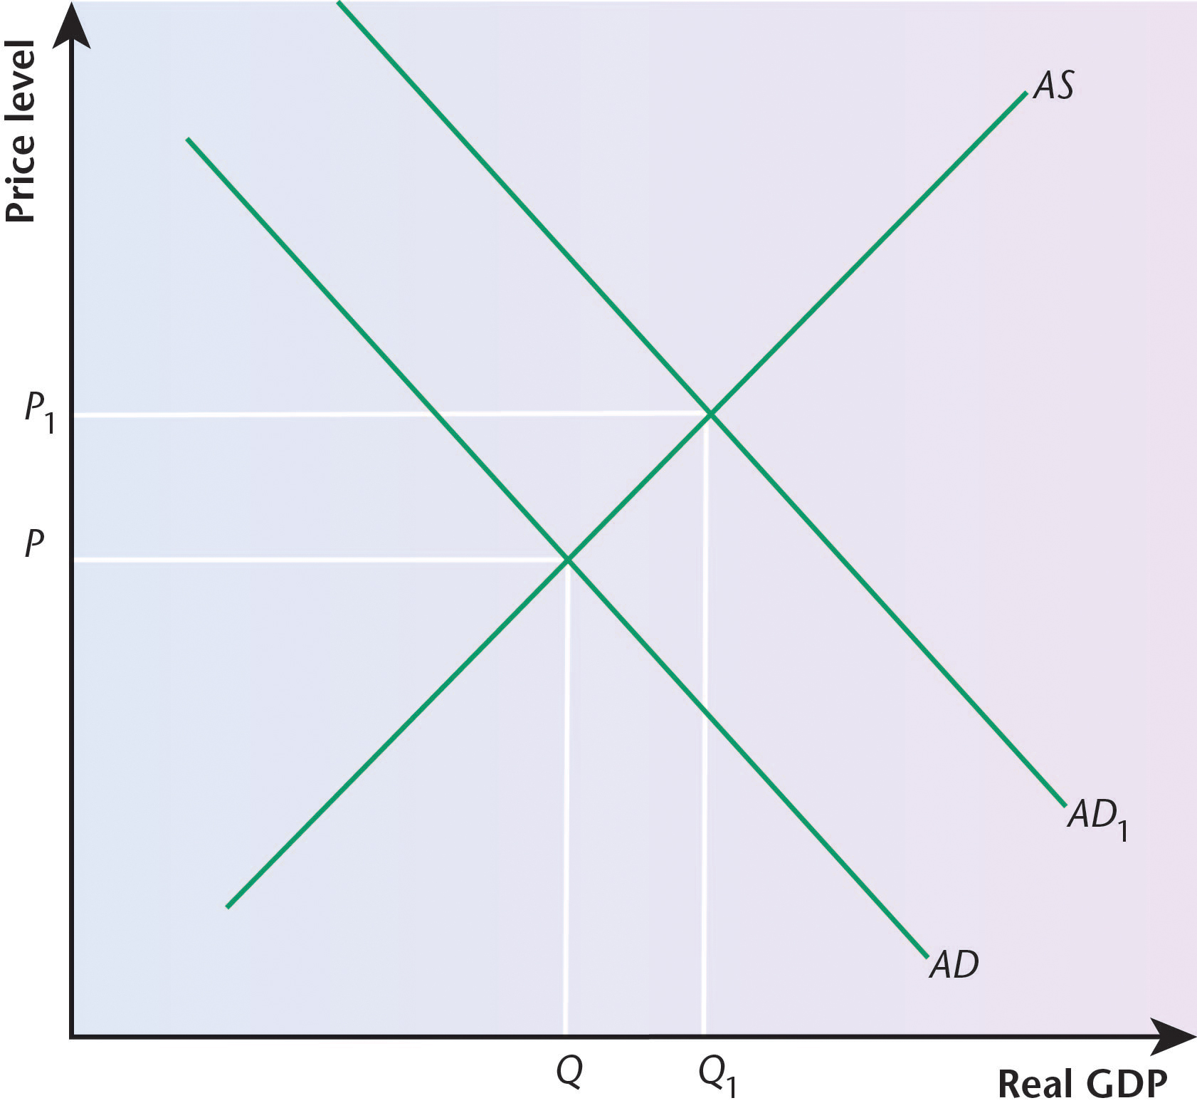
Figure 1
The diagram clearly shows the shift of the AD curve to the right, but the student could have made more of an attempt to incorporate the diagram into the answer, e.g. by referring to output increasing from Q to Q₁ and to the price level increasing from P to P₁. It would also have been useful if the term GDP had been explained as gross domestic product and if the concept of real had been explained in terms of the figure having been adjusted to take into account the effects of inflation.
In Figure 2, there is a shift of the AS curve to the right. This will also lead to an increase in the output level, in terms of real GDP, but in this case there will be a fall in the price level.
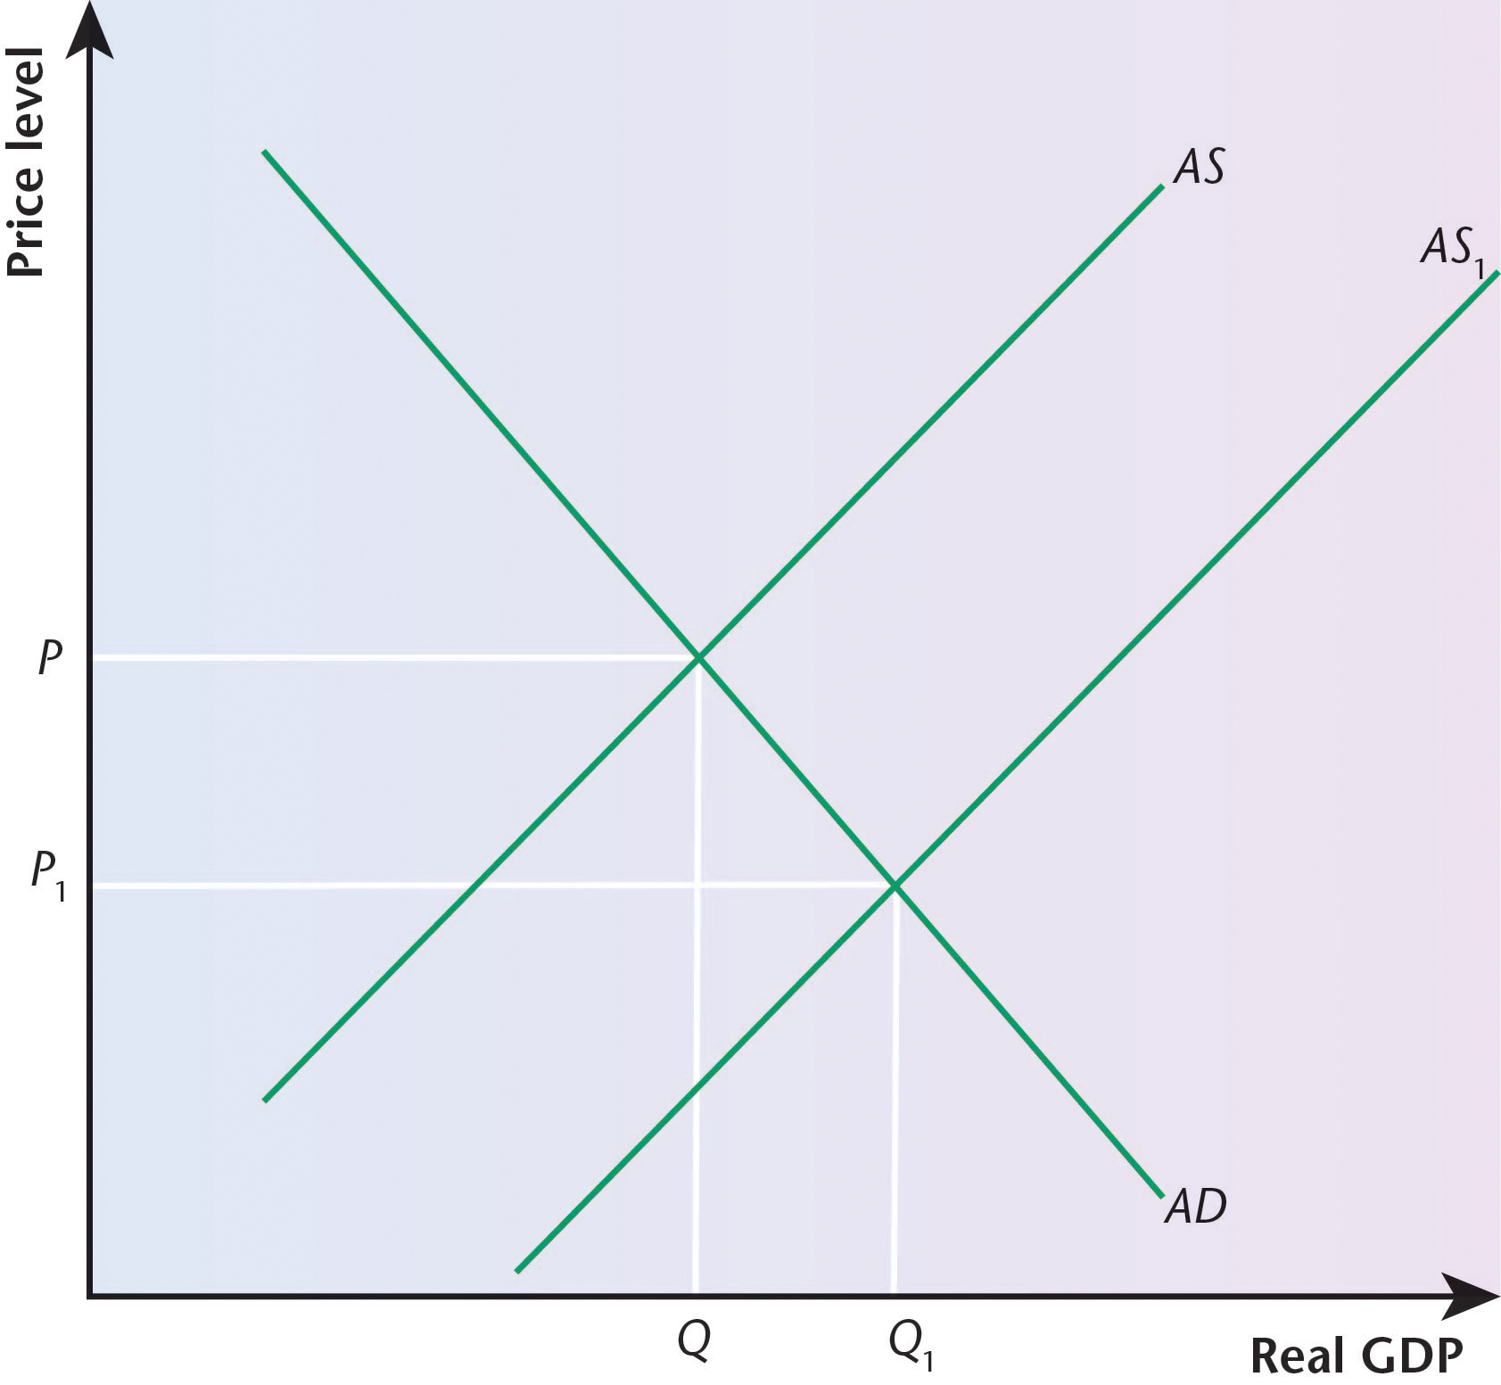
Figure 2
Again, the diagram is clear in showing the shift of the AS curve to the right, but the student could also have made a clearer link between the diagram and the answer, in terms of output increasing from Q to Q₁ and the price level falling from P to P₁.
The rightward shift of the AS curve will lead to an increase in output, as already indicated, and therefore there will be an increase in employment. However, in time, the AS curve will become increasingly inelastic, until it becomes perfectly inelastic. At this point, the full employment position will have been reached.
This is an important point to have made, stressing that the AS curve will eventually become perfectly inelastic, i.e. it will be a vertical straight line. It would have been helpful if a diagram had been included in the answer to show this.
In conclusion, changes in the AD and AS curves will have an effect on output and prices in an economy and employment will continue to increase with a rise in output until the AS curve becomes perfectly inelastic and it is not possible to supply any more.
This is a useful conclusion but, as has already been indicated, the discussion would have been helped by the inclusion of an appropriate diagram.
The circular flow of income, the concepts of leakages and injections, and a general awareness of the multiplier effect
10 The circular flow of income is a concept which emphasises the fact that there is a continuous flow of money around an economy. It stresses the idea that some income that is received will be spent. This then becomes income for somebody else. Part of that income will also be spent, becoming income for somebody else. This process will go on and on in a continual flow, with money coming into the flow from the injections and leaving the flow in the form of leakages and withdrawals.
11 The concept of the circular flow of income works on the basis that there will continually be income entering into the flow and income leaving the flow.
In a four-sector model of the economy, there will be three types of injection. These are investment, government expenditure and the money received from the sale of exports. Private sector firms will be spending, as will the government, and this money will be added to the money received from the sale of exports.
Again, in a four-sector model of the economy, there will be three types of leakage or withdrawal. These are savings, taxation and imports. Not all income will be spent, and the money that is not spent is saved. As well as putting money into the circular flow, the government will also take money out in the form of taxation. Finally, the money spent on imports will be a leakage or withdrawal from the flow.
12 Economists are interested in change, but it is possible to view the effects of change from different perspectives.
One way to approach change is to analyse a change in an average propensity. This means that the new total figure is divided by the number of units to give an average figure. For example, the average propensity to save is the average proportion of total income that is saved.
Another way to approach change, however, is to analyse a change in a marginal propensity. The term ‘marginal’ refers to just one change, e.g. the effect of an increase in income rather than the effect of total income. For example, marginal propensity to save is the proportion of an increase in income that is saved.
13 The concept of a marginal decision relates to the idea of a decision being taken at the margin. For example, if there is an increase in income in an economy, it would be useful to study the proportion of this last, or extra, income that is spent in some way.
The marginal propensity to save focuses on the proportion of an increase in income that is not spent, but saved. The idea of the margin stresses that it is the proportion of this extra income that is saved, not the proportion of all income that is saved (this would give an average, rather than a marginal, figure).
The marginal propensity to tax refers to the proportion of this extra or additional income that is taxed by the government. It is only concerned with the proportion of the extra income that is taxed, not the proportion of all the income.
Finally, the marginal propensity to import refers to the proportion of the additional income that is spent on the consumption of imported goods. Again it is the marginal, not the average, proportion that is significant.
14 The concept of the multiplier refers to the fact that an injection into the circular flow of income of an economy may produce an increase in national income that is greater than the initial injection. For example, if the injection is £1 billion, but the effect of this injection is an increase in national income of £1.5 billion, then the multiplier is equal to 1.5. It shows that there has been a magnified increase in national income, greater than the initial injection.
15 The multiplier shows the relationship between an injection into the circular flow of money and the resultant change in national income as a result of the initial injection.
It is important to know what the value of the multiplier is. A government might decide to inject money into an economy to stimulate demand and so reduce the rate of unemployment. However, if the size of the multiplier is larger than had been thought, too much money will be injected and this could contribute to a situation of inflation.
An example will illustrate this. If an economy is experiencing a high rate of unemployment, a government injection would help to stimulate aggregate demand, leading to a fall in the rate of unemployment. If the amount needed was £10 billion, and economists had estimated that the multiplier was 1.5, if £10 billion was injected, the overall effect would be to increase national income by £15 billion. This is more than was required and if such a significant increase in demand took place, the effect might be inflationary. However, if the government understood that the value of the multiplier was 1.5, and that national income needed to increase by £10 billion, then only just over £6.6 billion would need to be injected into the economy to bring about the desired increase in national income.
Thus, the multiplier concept plays a key role in the economy in guiding the government to inject just the right amount of money, without bringing about unintended consequences.
16 The concept of the multiplier is often analysed in terms of a positive effect on an economy. For example, a government that wishes to increase aggregate demand will want to have some idea of the likely multiplier effect to avoid the problem of any increase in demand being excessive, as this could lead to inflationary consequences.
It is also important to recognise, however, that there can be a negative multiplier effect in an economy. For example, if there is an increase in one of the leakages or withdrawals from the circular flow of income, such as an increase in taxation to reduce the level of aggregate demand in an economy, a government will need to have some idea of the likely multiplier effect because there is a danger that the reduction in demand may go too far. For example, the aim may be to use fiscal policy to reduce the level of demand to bring about a lower rate of inflation. In the UK at the moment, the rate of inflation is 2.9% as measured by the consumer price index, but the government’s objective is for it to be no higher than 2%. Taxation may be raised in an attempt to bring this about, but if the negative multiplier effect is greater than anticipated, this could have serious consequences for the level of unemployment in the economy.
Topic 2
Government economic policy objectives and indicators of national economic performance
Government policy objectives for the macroeconomy
1 Economic growth is defined in terms of the growth in output of an economy over a period of time. It can also be defined in terms of the growth of the productive potential or capacity of an economy.
2 Actual growth refers to a situation where there is a movement from within a production possibility curve or frontier to a position on the curve or frontier. A position within the curve indicates unemployed resources. Any position on the curve will indicate the full employment of economic resources.
Potential growth refers to a situation where there is a shift of the production possibility curve or frontier to the right, indicating that with a greater quantity and/or quality of resources, an economy would be able to produce more.
3 Economic growth is measured in the UK through changes in the value of its output over a period of time. This is done through changes in gross domestic product (GDP), which takes into account the value of what has been produced in the country, irrespective of the ownership of the economic resources.
One of the difficulties of its measurement is that although it takes into account the value of what has been produced within the geographical boundaries of the country, it does not take into account the ownership of the resources. If this were to be done, it would involve adding the value of net property income from abroad to give a figure for gross national product (GNP).
Another difficulty is the fact that the value of the output will be a nominal figure that does not take into account the possible effect of inflation. In order to overcome this problem, GDP is often expressed in terms of real GDP, i.e. having taken into account the effect of inflation.
4 Economic growth in a country can be caused by a number of factors. The main influence is the quantity and/or quality of resources. For example, the labour force of an economy may grow, enabling more to be produced, or the productivity of the existing labour force could be enhanced through training and education. This is known as an improvement in the human capital of an economy.
Investment in capital goods, such as equipment and machinery, can also enable more to be produced. An improvement in the capital:output ratio would enable this to take place.
An increase in a country’s savings ratio will provide the funds to enable investment to be financed.
Technological change can also help to generate economic growth as an economy will be able to benefit from technological progress.
5 The main trend in economic growth in the UK in the last 20 years has been economic growth of about 2.2% each year. This has not been an even trend, as the trade cycle, also known as the business cycle or the economic cycle, leads to fluctuations. But the long-run trend has generally been upwards.
However, there have been periods of recession where output has actually fallen. A recession is defined as two successive quarters of negative growth. Since the credit crunch of 2007–08, the UK has experienced a recession on two occasions, giving rise to the term ‘double dip recession’. It narrowly avoided going into recession again in 2013, which would have given rise to a ‘triple dip recession’.
Exam-style question
6 Student answer:
Economic growth, i.e. an increase in the real GDP of an economy over a period of time, has a number of advantages and disadvantages.
It would have been useful if the student had defined these concepts more clearly. GDP should have been explained in terms of gross domestic product, i.e. the value of the output produced within the geographical boundaries of a country, irrespective of who owns those resources. The student should also have explained the idea of a ‘real’ value in terms of taking into account the rate of inflation in an economy.
The benefits of economic growth include the advantages of greater output and greater production. This will benefit an economy because if more is produced, there will be more available for people to buy and this will increase the standard of living and quality of life of the people, although some of the output may be exported to other countries. If more is produced, this should lead to a reduction in the rate of unemployment.
The student could have pointed out that there will only be an increase in the standard of living of people on average if the growth of output is greater than the growth in population. If this is not the case, there will actually be a fall in GDP per capita. The comment about the likely fall in unemployment also needs to be qualified — it may be the case that economic growth comes about through a greater use of capital, rather than labour, and it is possible for economic growth to be associated with an increase in the rate of unemployment in a country.
Economic growth, however, can also have some disadvantages or costs. Growth represents an increase in GDP, but this could bring about more negative externalities in the form of greater pollution and congestion. Also, the increase in GDP is in terms of quantity. It would be necessary to know exactly what is being produced, because the growth could largely represent an increase in armaments.
There may also be a negative effect on the quality of life of people, especially if high growth rates are associated with high rates of illness.
This is a useful section in the answer. The student clearly recognises that there may be some costs of growth, especially in terms of the effect on the quality of life in a country.
One particular cost of growth can be seen in terms of its possible effect on the environment. For example, climate change and deforestation can be the result of high rates of economic growth. This is why a number of economists have been paying more attention to the concept of sustainability.
There is a reference to sustainability, a concept that is included in the question, but it is not clear whether the student fully understands what is meant by this term. The idea of sustainability stresses the point that many resources cannot be replaced and so a decision to exploit, rather than conserve, them has implications not just for existing generations, but also for future generations. The discussion of deforestation could have been developed more fully, for example, to stress the element of sustainability, e.g. the need to plan for replanting.
In conclusion, it is clear that while there are many potential benefits of economic growth, there is also the possibility of a number of disadvantages taking place.
The conclusion is rather superficial and really needed to be developed more fully. The student could have selected one or two main benefits and costs of growth and contrasted them before coming to a judgement about the consequences of economic growth for an economy.
7 Unemployment refers to a situation where labour is able and willing to work, but is unable to find work at that particular time. In such a situation, the labour is an unused economic resource.
8 Unemployment in the UK is measured in one of two ways. First, it can be done through the claimant count. This refers to the number of people who officially register as being unemployed. The difficulty with this form of measurement is that not all unemployed people register in this way, e.g. they may not need the money.
Second, it can be done through the Labour Force Survey. This measurement of unemployment is based on the approach of the International Labour Organization. It uses sample surveys to measure the number of people unemployed. The difficulty of this approach is that it depends on how representative the sample is.
9 There are a number of different causes of unemployment. Demand-deficient unemployment occurs as a result of the level of aggregate demand in an economy being too low. Such a situation can occur as a result of a slump in the trade cycle, and so it is also known as cyclical unemployment.
Structural unemployment comes about as a result of a change in the structure of an economy, e.g. as a result of industries declining and needing fewer workers. Sometimes, this is due to changes in technology, as production becomes more capital-intensive, when it is known as technological unemployment. Sometimes, it can be concentrated in certain areas, giving rise to regional unemployment.
Unemployment can also be a temporary situation, when people are in the process of leaving one job and starting another. This type of unemployment is known as frictional unemployment.
Sometimes, unemployment occurs because the nature of the work is casual, e.g. seasonal jobs.
Real wage unemployment occurs where trade unions have used their power and influence to push wages too high, leading to employers laying off some of the workers.
10 During the last 20 years, the level of unemployment in the UK has generally been higher than has been the case in the past. This is mainly because of the existence of slumps or recessions in the trade cycle and because of policies introduced to reduce aggregate demand and bring down the rate of inflation. This relationship between the inflation rate and the unemployment rate can be shown through the Phillips curve.
Before the credit crunch of 2007–08, the rate of unemployment was about 5%, but since then it has been higher. In 2013 it was between 7% and 8%.
Exam-style question
11 Student answer:
Unemployment can have a number of negative consequences for an economy. The main one is that it represents a waste of resources and so there is a loss of potential output for an economy. If the unemployment is cyclical, this will be less of a problem because it would be hoped that eventually the trade cycle will ‘pick up’ and the slump will lead to a recovery.
It is important to stress this loss of potential output in an economy. In this sense, unemployment is a terrible waste of resources. The student might have discussed the trade or business cycle more fully in relation to cyclical unemployment, e.g. it could also have been referred to as being demand-deficient.
If, however, the unemployment is structural, the consequences will be more dramatic. This is because structural unemployment comes about as a result of structural changes in the economy. There are always likely to be declining or sunset industries which will need fewer workers. Some of these workers may be able to find work in other parts of the economy, but for some of the workers this will not be possible.
This is a useful section on structural unemployment, but the student might have widened the discussion by bringing in the idea of technological unemployment.
Some of these declining industries have been concentrated in certain parts of the country and so this structural unemployment often gives rise to areas of high rates of regional unemployment. Coal mining, steel production and ship building are examples of declining industries in the UK that have been concentrated in certain parts of the economy.
The student clearly recognises the situation with regard to some declining industries, especially in terms of the regional concentration of many of these in certain parts of the country.
Some types of unemployment may actually be seen as positive for an economy. For example, frictional unemployment comes about as a result of workers moving from one job to another. This can be seen as an example of a dynamic economy, with workers benefiting from geographical and occupational mobility of labour.
It is important to stress the potential advantages of workers moving from one type of work to another, even if this may involve a short period of unemployment.
Another potentially positive aspect of unemployment is in terms of the trade off with inflation. If there is a relatively high rate of unemployment in an economy, this will tend to lower the level of aggregate demand and this could lead to a lessening of inflationary pressures in the economy.
This section could have been developed more fully. There could have been a reference to the Phillips curve and it would have been useful if a diagram of the Phillips curve had been included to support the discussion.
In conclusion, there are a number of negative consequences of unemployment in an economy, especially in terms of a wasted resource, but there are also potential benefits, such as bringing down the rate of inflation.
The student makes an attempt to conclude the discussion by a reference to an advantage and a disadvantage of unemployment, but it could have been developed more fully than this, especially in relation to the different possible types of unemployment that can exist in an economy.
12 Inflation refers to a persistent and sustained increase in the general or average level of prices in an economy over a period of time, usually 1 year.
13 Inflation is measured in the UK through the construction of a prices index. There are a number of different indices in use, but the two main ones are the consumer prices index (CPI) and the retail price index (RPI). The main difference between them is that the CPI excludes housing costs, such as the cost of mortgage payments, but the RPI includes them.
The main difficulties in the construction of an index are the selection of the base year, which is given the value of 100, the decision as to which goods and services are to be included in the survey of prices and the weightings to be given to the different products to reflect their relative importance in the expenditure patterns of households.
14 The two main causes of inflation are cost-push and demand-pull.
Cost-push inflation refers to a situation where an increase in the general level of prices is caused by rising costs of production, such as the cost of wages or component parts. The cost of raw materials may have increased as a result of a fall in the exchange rate, causing the prices of imported materials to rise.
The other main cause of inflation is demand-pull. This is where the level of aggregate demand in an economy is greater than the capacity of the economy to supply enough products to satisfy the demand. This situation of excess demand forces up the general level of prices.
15 The highest rate of inflation in the UK in recent years was about 26% in the early 1970s. Since then, the inflation rate has ranged between about 2% and 6%. In 1997, the target for the inflation rate was established at 2.5%, but since then this figure has been reduced to 2.0%. Governments in recent years have struggled to bring inflation down to as low as 2%.
Exam-style question
16 Student answer:
Inflation refers to a persistent and sustained increase in the general level of prices in an economy over a period of time.
It is always a good idea to start an answer with a clear definition of the key term.
It is generally believed that the negative consequences of inflation are more significant than any positive effects. One of the most important of these negative consequences is the erosion of a given sum of money, i.e. the value or purchasing power of a nominal amount of money will fall.
It is important to stress the significance of the erosion of the value of a given sum of money as a result of inflation, although this section might have been developed more fully: for example, by discussing the effect that it will have on the value of savings — a high rate of inflation may discourage people from saving. The student could also have mentioned the uncertainty that inflation can bring to an economy.
Another significant consequence is in terms of international trade. If a country is experiencing a high rate of inflation, the prices of its exports will rise rapidly and if demand is price elastic, this will cause the demand for them to fall.
This is a valid point, but the student could have gone further by stating that what needs to be considered is a country’s rate of inflation when compared to the rates of its main competitors.
A further negative consequence is that it brings about a redistribution of income in an economy. For example, those people on fixed incomes will be particularly hit by inflation.
The student might have supported the discussion here by referring to some examples of those on fixed incomes. For example, many pensioners live on payments that are not adjusted to take into account the effect of inflation.
There are, however, certain positive consequences of inflation. For example, borrowers gain because if somebody has borrowed money, inflation will reduce this debt in real terms.
The discussion of possible positive consequences might have been developed more fully. For example, inflation can lead to an increase in profits for firms, as long as they can ensure that their costs of production do not rise by as much as the increase in prices.
In conclusion, it can be seen that inflation has a number of consequences, both negative and positive, for an economy.
This is a rather superficial conclusion. It would have been better if the student had made more of an effort to summarise some of the main consequences of inflation before coming to a judgement about them.
17 The balance of payments is a record of all the transactions involved with trade between different countries, in terms of the export and import of visibles and invisibles, capital movements and the financial account.
18 The current account of the balance of payments is made up of four parts:
(i) The trade in goods, i.e. trade in visibles. This gives rise to either a visible trade surplus or a visible trade deficit.
(ii) The trade in services, i.e. trade in invisibles. This gives rise to either a surplus or a deficit in the invisible balance.
(iii) Income. This covers net incomes to workers and net investment income in the form of dividends and interest payments.
(iv) Current transfers. These include charitable donations, gifts and foreign aid.
19 The visible balance has generally been in deficit over this period, i.e. the UK generally imports more visible goods than it exports.
The invisible balance has generally been in surplus over this period, i.e. the UK is usually a net beneficiary of trade in invisible services, such as in finance and insurance.
The income account is usually in surplus, especially in terms of investment income.
The current transfers account is usually in deficit.
Exam-style question
20 Student answer:
The main cause of a deficit on the current account of the balance of payments is usually a deficit in the visible trade balance, i.e. a country is importing more goods than it is exporting.
This is often the main cause of such a situation, but the student could have brought the other parts of the current account of the balance of payments into the discussion, i.e. the trade in invisibles, the income account and the current transfers account.
There are a number of possible consequences of this. First, a government may seek to encourage exports by assisting exporting firms, e.g. by providing a subsidy. This would have the effect of reducing the costs of production and, if this could be translated into lower prices, this should lead to an increase in exports, assuming that demand is elastic. Another consequence is that a government may feel the need to introduce protectionist policies, such as tariffs or quotas, to reduce the extent of the imports. Alternatively, a consequence could be a depreciation in the foreign exchange value of the currency.
The student could have focused more clearly on the fundamental issue, i.e. the uncompetitive nature of the products being produced. There is an argument for stating that this should have been faced because providing a subsidy can lead firms to hide behind this financial support without becoming more efficient. The reference to elasticity of demand could have been developed more fully. There is a reference to tariffs and quotas, but these could have been more clearly distinguished. There is a consideration of the possible depreciation of the exchange rate, but this term is not really explained. A diagram would have been helpful to aid the discussion at this point.
The main cause of a surplus on the current account of the balance of payments is usually a surplus in the visible trade balance, i.e. the country is exporting more goods out of the country than it is importing.
Again, the discussion could have been widened to include the other elements of the current account of the balance of payments.
It might be thought that this is a good position for a country to be in, but if one country persistently has a current account surplus, this means that other countries will be having deficits and they may be forced to introduce protectionist measures. Also, the surplus will lead to an appreciation of the currency, making imports less expensive. This could lead to an increase in the number of imports into the country, affecting the prospects of domestic producers. Also, the increase in the exchange rate will make the country’s exports less competitive, especially if demand is elastic.
There needed to be a fuller discussion of the possible effects on the exchange rate and the concept of an appreciation in the exchange rate is not really explained.
In conclusion, it is clear that deficits and surpluses in the current account of the balance of payments can have significant consequences.
This is a rather limited conclusion and really needed to be developed more fully by offering a balanced summary of the two perspectives before coming to a judgement.
21 Income redistribution refers to the fact that in a market, there may be an unequal distribution of income. Redistribution refers to the deliberate attempt by a government to bring about a more equal distribution of income, such as through the use of a progressive tax system.
22 Income redistribution can be a government objective because it is not prepared to accept the unequal distribution that can result in a market with no government intervention. In a sense, this is a normative judgement as to how income should be distributed in an economy, but a government could use a progressive system of income tax, along with a system of benefits, to make the distribution of income more equitable. Such an approach can be criticised, however, as progressive taxation can bring about a disincentive to work.
23 Economic stability results from a combination of policies that are in the long-term interests of an economy, e.g. a low rate of inflation and unemployment, a sustainable rate of economic growth and a balance in the deficits and surpluses of the balance of payments over a period of time. The key aspect is that policies should be designed to create long-term, rather than short-term, objectives.
24 Economic stability relates to the achievement of policy objectives over the long term. The idea is that there should not be dramatic changes in the economy over a period of time as this would create uncertainty and would be likely to reduce confidence in the future.
A government would, therefore, aim to establish objectives that work as a benchmark. For example, the rate of inflation in an economy can vary quite a lot, but the UK government has declared its objective of aiming to keep this to no more than 2%.
The use of data to measure economic performance, including international comparisons
25 GDP refers to gross domestic product. This measures the value of all that has been produced in an economy within the geographical boundaries of the country, irrespective of who owns the factors of production that have produced this output. ‘Real’ means that this value has been adjusted to take into account the effect of inflation.
Exchange rates
26 An exchange rate is the price of one currency in terms of another. It refers to the external value of a country’s currency. It is determined just like any other price in a market, i.e. by the intersection of demand and supply, establishing an equilibrium price and an equilibrium quantity. In the case of currency that is traded in this way, the market is the foreign exchange market.
27 A floating exchange rate system means that it is determined in a market just like any other price in a market, i.e. by the forces of demand and supply. The market in this case is the foreign exchange market.
The demand curve for the currency is downward-sloping, just like any other demand curve. This demand refers to the demand to change other currencies into sterling in order to buy UK goods and services.
The supply curve of the currency is upward-sloping, just like any other supply curve. This supply refers to the need to change pounds sterling into other currencies in order to buy goods and services made abroad.
The equilibrium price and equilibrium quantity are determined where demand and supply intersect. If the demand curve shifts to the right, the exchange rate will rise or appreciate. If the supply curve shifts to the right, the exchange rate will fall or depreciate.
Exam-style question
28 Student answer:
A fall, or depreciation, in the exchange rate will have the effect of lowering export prices. This will help to make the exported goods and services more competitive. If the price elasticity of demand is elastic, the lower price should lead to an increase in demand. This will have the effect of increasing aggregate demand in the economy. This could affect the macroeconomy in a positive way, by contributing to an increase in employment and economic growth.
The student understands the link between a change in the value of an exchange rate and the price of products. The assumption here is that the price elasticity of demand for exports is likely to be elastic, but it may in fact be inelastic. The price of a product is only one possible influence on demand and if certain products have a bad reputation for reliability, changes in price as a result of changes in the exchange rate will not necessarily have much effect on the demand. The question refers to changes in an exchange rate, either appreciation or depreciation, but in this section the student only refers to a fall or depreciation.
The fall in the exchange rate will, however, raise import prices. This will not be a major problem if the demand for imports is price elastic, but in many countries the demand for imports is relatively price inelastic. This could be the case with imported raw materials and component parts that are needed in the production of goods. If the demand is inelastic, this may have an inflationary effect on the economy. It may also have a negative effect on the current account of the balance of payments, if the value of the imports is greater than the value of the exports.
Again, the answer only deals with the possible consequences of a fall or depreciation in the exchange rate of a currency. If a question refers to ‘changes in an exchange rate’, it is best to consider both an appreciation and a depreciation. The student recognises the possible inflationary impact of the depreciation in relation to higher import prices. There is also a reference to the possible effect on the current account of the balance of payments, but it should be remembered that the visible trade balance is only one of four elements in that account.
In conclusion, it is clear that changes in the exchange rate can affect the macroeconomy in a number of ways.
This is a rather limited and superficial conclusion that needed to be developed more fully. For example, the student could have contrasted the positive and negative consequences of changes in an exchange rate.
Topic 3
The application of macroeconomic policy instruments and the international economy
The nature of policies
1 Fiscal policy refers to the policies that relate to the raising of revenue, public expenditure and the balance between these.
2 Fiscal policy refers to the balance between public revenue and public expenditure. Governments will generally aim for a balanced budget over a period of time, i.e. the imbalances between revenue and expenditure should even out approximately over a period of time.
Sometimes, however, the fiscal position will involve expenditure repeatedly being greater than revenue. This excess of expenditure over revenue is known as a fiscal deficit. A government may deliberately plan to spend more than is being received as a way of stimulating the level of aggregate demand in an economy.
3 Monetary policy is concerned with the price of money, i.e. the interest rate, and the stock or supply of money in an economy. Monetary policy can be used to influence the level of aggregate demand in an economy.
4 Whereas fiscal policy and monetary policy are essentially concerned with the demand side of the economy, supply-side policy is concerned with ways in which policies can be introduced in order to help markets work more efficiently. The benefit of this is that supply can be increased from the given resources in an economy.
5 One supply-side measure would be to encourage the training, education and skilling of the labour force. This would improve the quality of the labour force, making it more flexible and adaptable, and this would help to improve the degree of occupational mobility in a country.
A second supply-side measure would be to encourage the extent of competition in markets. This could involve decisions to privatise certain industries to allow for greater competition between rival firms, increasing the level of efficiency in the market. The rail industry in the UK is an example of such privatisation.
A third supply-side measure would be to reduce the benefits that are made available to those people who are unemployed. If the gap between the benefit and the wage paid to a worker were increased, it is believed that this would encourage unemployed workers to make more of an effort to seek employment.
The use and effect of these policies
6 Fiscal policies, such as reducing taxation and/or increasing expenditure, can increase the level of aggregate demand in an economy. A shift of the AD curve to the right would increase the level of real GDP, contributing towards an increase in the level of employment in the economy.
Monetary policies, such as reducing the interest rate and/or increasing the money supply, could also increase the level of aggregate demand in an economy. Again, a shift of the AD curve to the right would increase the level of real GDP, contributing towards an increase in the level of employment in the economy.
Supply-side policies, such as increasing the training given to workers or privatising an industry, could increase the aggregate supply in an economy. A shift of the AS curve to the right would increase the level of real GDP, contributing towards an increase in the level of employment in the economy.
7 Fiscal policies, such as increasing taxation and/or reducing expenditure, can reduce the level of aggregate demand in an economy. A shift of the AD curve to the left would reduce the price level.
Monetary policies, such as increasing the interest rate and/or reducing the money supply, can also reduce the level of aggregate demand in an economy. A shift of the AD curve to the left would reduce the price level.
Supply-side policies, such as improving the skills of workers, could increase the level of aggregate supply in an economy. A shift of the AS curve to the right would reduce the price level.
8 Fiscal policies, such as reducing corporation tax on profits and/or increasing expenditure on investment projects, can increase the level of aggregate demand in an economy. A shift of the AD curve to the right would increase the level of real GDP, bringing about economic growth.
Monetary policies, such as reducing the interest rate to make borrowing cheaper and/or increasing the money supply, can also increase the level of aggregate demand in an economy. Again, a shift of the AD curve to the right would increase the level of real GDP, bringing about economic growth.
Supply-side policies, leading to an increase in the productivity levels of workers, can increase the aggregate supply in an economy. A shift of the AS curve to the right would increase the level of real GDP, bringing about economic growth.
9 If there is a deficit in the current account of the balance of payments, a reduction in aggregate demand in an economy would reduce the level of demand for all products, including those that are imported.
Fiscal policies, such as increasing taxation and/or reducing expenditure, can reduce the level of aggregate demand in an economy. A shift of the AD curve to the left could contribute to a reduction (or even elimination) of the deficit in the current account of the balance of payments.
Monetary policies, such as increasing the interest rate and/or reducing the money supply, can also reduce the level of aggregate demand in an economy. Again, a shift of the AD curve to the left could contribute to a reduction in the size of the current account deficit.
These fiscal and monetary policies would lead to a reduction in the demand for imports. Another way, however, to reduce or eliminate a deficit in the current account of the balance of payments would be to stimulate the efficiency of supply. If exports could be produced more efficiently and cheaply, this could encourage the demand for them in other countries. Supply-side policies to improve the training and education of workers should lead to an increase in their productivity and this would cause a shift of the AS curve to the right.
Exam-style question
10 Student answer:
Fiscal policies can be very effective in achieving a government’s macroeconomic objectives. A fiscal deficit can stimulate the economy through an increase in aggregate demand, contributing to a reduction in unemployment and a stimulus to economic growth. Of course, a government will need to take into account the size of the multiplier in planning for a particular injection into the circular flow of income. One problem, however, is that a stimulus to an economy can bring about a rise in the level of inflation. There is also the risk that much of the increased income could be spent on imports, creating a difficulty for the current account of the balance of payments.
The student could have considered the implications of building up fiscal deficits over a number of years, especially in terms of the cost of borrowing that would be involved to cover these deficits. There is a reference to the multiplier, but the discussion of what this and why it is important could have been developed more fully.
Monetary policies can also be very effective in achieving a government’s macroeconomic objectives. An increase in the rate of interest and/or a reduction in the money supply could contribute to a fall in the level of aggregate demand. This can be effective in reducing the rate of inflation. It can also be effective in reducing demand, including the demand for imported goods. Such a restrictive monetary policy, however, could lead to a decrease in the rate of economic growth and this could bring about a rise in the rate of unemployment in an economy.
The student could have taken the discussion further by commenting on whether demand is likely to be interest elastic if there is a change in the interest rate. The student could also have gone further in relation to the demand for imported goods, such as by bringing in the concept of the marginal propensity to import.
Supply-side policies, such as improving the training and hence the productivity of workers, can be very effective in achieving the macroeconomic objectives. They can bring about an increase in the level of economic growth in an economy and this could contribute to a reduction in the level of unemployment. A shift of the AS curve to the right would lower the price level and if goods could be supplied more efficiently and cost effectively, this could make them more competitive in world markets, contributing to a possible decrease in the deficit in the current account of the balance of payments.
The student could have pointed out that an increase in economic growth could have come about as a result of a movement from labour-intensive production to capital-intensive production. If this was the case, it would not necessarily have contributed to a fall in the level of unemployment in the economy. The student could also have mentioned that the price of products is not the only influence on the demand for exported goods — a reduction in price does not guarantee a significant increase in demand. This could have been linked with the concept of price elasticity of demand.
Each of these policies has various advantages and disadvantages and so the best solution is probably to use a combination of them.
The conclusion is rather limited and really needed to be developed more fully. For example, some of the more important advantages and disadvantages could have been contrasted before coming to a judgement.
Possible conflicts between policy objectives
Exam-style question
11 Student answer:
A government will aim to achieve a number of policy objectives simultaneously, but this will not always be possible.
It might have been useful, in the first paragraph, if the student had indicated what these policy objectives usually are.
One key objective is to keep the rate of inflation down to what is generally seen as an acceptable figure. This figure in the UK is 2%. If the figure rises above this, as measured by the consumer price index, the government will need to try to reduce the level of demand in the economy, such as by increasing the interest rate. If the level of demand does fall, this could help to bring down the rate of inflation.
The term ‘acceptable figure’ is rather vague — the student could have been clearer on inflation targets. There needed to be more of a discussion of how the increase in the interest rate would be likely to affect demand.
It may also help to bring down a deficit in the current account of the balance of payments. Governments usually aim for stability in the current account, i.e. there should be roughly a balance of deficits and surpluses over a number of years. In the UK, the current account has usually been in deficit, particularly in the visible trade section, and so there is not likely to be a conflict between policies which aim to reduce the rate of inflation and the size of a current account deficit at the same time.
A conflict could occur, however, in relation to the other two main macroeconomic objectives. Governments usually aim for the economy to grow at a reasonable rate over a period of time. In the UK, this has averaged out at about 2.2% each year. There have, however, been two recessions in recent years and so any policies designed to reduce the level of aggregate demand in an economy are likely to conflict with this objective.
The student clearly recognises that there is likely to be a conflict in this situation.
Another aim is to reduce the level of unemployment. In the UK, the aim has generally been to keep the unemployment rate down to about 4% or 5% of the labour force. Policies designed to reduce the level of aggregate demand in the economy, however, are likely to lead to an increase in the level of unemployment.
Again, the student has recognised the inherent nature of this potential conflict.
It should therefore be seen that it is very difficult for a government to simultaneously achieve all of its macroeconomic objectives at the same time.
This is a rather limited conclusion that needed to be developed more fully, such as in relation to examples of the most obvious conflicts.
The general nature and benefits of international trade
12 Free trade refers to the idea that countries in the world can trade with each other without this trade being restricted or hindered by the existence of various import controls, such as tariffs and quotas. The existence of free trade enables the advantages of comparative advantage to be gained, especially in relation to the growth of output in the world.
13 The theory of comparative advantage is based on the idea that countries can benefit from specialisation in those areas of production where they experience the lowest opportunity cost. These differences in efficiency and opportunity cost come about because of the fact that the quantity and quality of factors of production are not equally distributed throughout the world. These are known as factor endowments and countries will utilise these endowments as effectively as they can. For example, a country such as China has a large population and so has an abundance of labour — it has generally tended to concentrate, therefore, on labour-intensive methods of production. Singapore, on the other hand, only has a population of about 5 million and so it has tended to concentrate on capital-intensive methods of production.
14 International trade between countries is encouraged because of the potential advantages that can be gained from such trade.
Trade allows countries to benefit from the increase in output resulting from specialisation. In this way, the consumers have a wider range of products to choose from at a lower price. In essence, trade allows countries to consume outside of their production possibility frontiers.
It may also make it easier, as a result of the specialisation, for production to benefit from economies of scale, with the greater output produced at a lower unit cost.
Trade has contributed significantly to economic growth and an increase in standards of living in the different countries of the world.
Free trade vs protectionism
15 Protectionism refers to those methods or policies that protect domestic producers in a country from international competition. They are therefore restrictions on international trade.
16 The World Trade Organization was set up in 1995 and now has 159 member countries.
Its main purpose is to encourage free trade through its supervision of international trade. It deals with the regulation of trade between the member countries and provides a framework for negotiating trade agreements. There are a number of WTO agreements which the member countries are required to adhere to. It can also be involved in the resolution of trade disputes between member countries.
The Doha Round of negotiations has not been as successful as had been hoped. One of the difficulties has been over the provision of subsidies to farmers in a number of countries.
17 Some countries decide to protect their domestic producers for a variety of reasons.
One particularly important reason could be to support an infant industry in an economy, i.e. one that has only recently been established and which is therefore not yet ready to compete in international trade with more established firms from other countries. These industries can also be referred to as sunrise industries.
Another argument might be to protect declining industries, i.e. those industries which are in the process of decline, but which a government might want to support for at least a limited period of time to enable workers to find new jobs in other industries. If this was not the case, there could be a dramatic increase in the rate of unemployment in the country. These industries are also known as sunset industries.
One argument that is often regarded as relatively strong is opposition to dumping. Dumping refers to the fact that imported goods are not only cheap, but they are actually being sold at a price that is below the cost of production in the home country.
A government could decide to impose a tariff as a means of raising revenue, especially on those imported goods for which the price elasticity of demand is relatively inelastic.
Even though the advantages of free trade are well known, it is therefore the case that some countries may prefer to use protectionist methods to protect at least some of their domestic producers for a period of time.
Methods of protectionism
18 A tariff is a tax or duty that is imposed on an imported good. It will be included in the price of the product and, as long as demand is elastic, the higher price should discourage consumption of the product.
A quota is a limitation on the amount of imports that come into a country. It can be in the form of a limit on the number of products allowed in, the value of the products or the market share that they represent.
19 There are a number of protectionist methods, other than a tariff or a quota, that could be used to reduce the number of imports coming into a country.
A subsidy is a financial payment that is paid to a producer to lower the costs of production and, therefore, the price to be charged. If domestic producers are supported by subsidies, this will make their goods more competitive and this is likely to reduce the demand for imported goods.
Exchange controls refer to restrictions on the currency that is made available to pay for trade. Imports could be reduced if it is made more difficult to obtain the money to pay for them.
An embargo is an actual ban on the importation of products. This usually refers to imports from one country or a specific group of countries.
Administrative procedures and restrictions can be used to make the process of importation more difficult because of all the ‘red tape’ that is involved.
Voluntary export restraints refer to a situation where a country tries to persuade another country to limit its exports voluntarily. This tactic can be successful because if it is not agreed, there can be a threat of bringing in protectionist methods.

