WORKBOOK ANSWERS

OCR AS Economics Unit F581

Markets in Action
This Answers document provides suggestions for some of the possible answers that might be given for the questions asked in the workbook. They are not exhaustive and other answers may be acceptable, but they are intended as a guide to give teachers and students feedback. The student responses for the longer essay-style questions (green text) are intended to give some idea about how the exam questions might be answered. The examiner comments (blue text) have been added to give you some sense of what is rewarded in the exam and which areas can be developed. Again, these are not the only ways to answer such questions but they can be treated as one way of approaching questions of these types.
Topic 1
The reasons for individuals, organisations and societies having to make choices
The economic problem and factors of production
1 The economic problem is essentially the existence of scarce resources, i.e. there are infinite wants, but finite resources to satisfy those wants. The scarce resources are the four factors of production: land, labour, capital and enterprise. There are insufficient resources, in terms of both the quantity and quality, to satisfy all the demands that are put on them. As a result of the imbalance between needs and wants, choices have to be made — all these resources have potential alternative uses.
2 Land: the natural resources in an economy, such as agricultural resources in the soil.
Labour: the factor of production which involves people contributing to the production process. It can be seen in terms of both the quantity and quality of labour in an economy. It is sometimes described as human capital.
Capital (in this context): the human-made aids to production, such as equipment, tools and machinery.
Enterprise: the taking of risk in combining the other factors of production to produce something which will lead to the making of a profit.
3 The process of production involves the combination of the four factors of production, as in the example of the production of motor vehicles.
Land is required to build a factory, such as at Cowley in Oxford. Labour is required in the production process to carry out a range of manual tasks. These will vary in terms of the level of skill and training required. Labour will also be required in a variety of managerial and administrative positions.
Capital is required in the form of a variety of equipment, machinery, robots and tools needed on the production line. Computer equipment will also be required throughout all stages of the production, research and development, administration and management process.
Enterprise is needed in order to take the risk of bringing the other factors of production together to produce products.

Exam-style question
4 Student answer:
With labour-intensive production, labour is more important than capital in the production process. With capital-intensive production, capital is more important than labour in the production process.
The explanations of the meaning of both labour-intensive and capital-intensive production are rather vague. It would have been better if the student had specifically referred to the labour:output ratio and the capital:output ratio.
An advantage for individuals is that there will be more capital, i.e. more tools and equipment, to be used in the process of production and this should benefit the individual in terms of a greater level of productivity. If wages are linked to productivity levels, this will benefit the individual in terms of the remuneration gained from the employment.
It is appropriate to make the link with productivity, but the student does not precisely define what is meant by productivity in terms of the output per worker per period of time. The link with remuneration is valid, but this might have been developed more fully, for example by suggesting whether such a wage rise might be a real increase in wages in relation to the level of inflation in an economy.
An advantage for organisations is that once the capital equipment is installed and paid for, it should lead to an increase in profit resulting from the greater level of production. Also, capital equipment can be used 24/7 so it will contribute to more output than labour.
This section might have been developed more fully. For instance, the reference to the contrast of capital with labour might have gone further, such as in terms of the capital not being restricted by days off for sickness or industrial disputes.
An advantage for societies is that many of the very boring and monotonous tasks involved in the production process can now be carried out by machines rather than labour and this will reduce the level of disenchantment and alienation experienced by workers.
This is a valid point.
On the other hand, however, there are potential disadvantages for all three. A move towards capital-intensive production is likely to lead to a lowering of demand for labour. This could have a negative effect on wage negotiations and could also lead to a situation where some of the labour force are no longer needed and are made redundant.
The link with wages paid to labour is a good point, but it could have been developed more fully, such as in relation to demand and supply factors in the determination of wages. The reference to some workers being made redundant might have been linked with this particular type of unemployment, i.e. technological unemployment.
A potential disadvantage for the organisation is the cost of purchasing the capital equipment. The money needed to pay for it may have to be borrowed. Also, if the machinery is going to be used 24/7, this is likely to lead to it breaking down more often.
This section could have been developed more fully. For example, there is a reference to the possible need to borrow money to pay for the capital equipment, but the student could have linked this with the rate of interest to be paid on any funds borrowed from a financial institution. There could also have been a reference to the difficulties of raising finance since the credit crunch of 2007–08. In terms of the reference to the machinery breaking down more often, this could have been linked to the costs of maintenance and repair and to the issue of depreciation over a period of time.
A potential disadvantage for societies could be the negative effects of a rise in the level of unemployment. If some workers are no longer needed, they may lose their sense of self-worth and this could lead to problems in the family and possibly an increase in the level of crime.
The student might also have made the point that such problems might be localised in particular areas of the country.
In conclusion, although there are a number of potential advantages of the move from labour-intensive to capital-intensive production for all three, there are also potential problems for all of them.
It is always good to end with a conclusion, but in this case it is rather superficial. There might have been an attempt to balance the various advantages and disadvantages of such a change, coming to a judgement as to whether overall such a change would be advantageous or not to the three categories.
Choice, exchange and specialisation
5 Specialisation refers to a situation in which individuals, firms or whole economies concentrate on the production of those goods and services in which they have an advantage. For example, the Scottish economist, Adam Smith, emphasised the importance of the division of labour. The production process could be broken up into a number of specific tasks and particular individuals would then concentrate on carrying out those specific tasks. The example that he used was a pin factory.
6 Adam Smith’s original analysis of the potential impact of specialisation on the process of production was in relation to the production of pins, but the principle can be applied to any production process where a number of separate tasks can be identified.
This is the case in the production of motor cars. The task of producing a motor car can be broken down into a number of separate tasks, such as in relation to the engine, the gearbox, the lights, the sound system, the tyres and many others. If all these tasks were performed by one person, production would be very slow.
However, if these tasks can be broken down and carried out by individuals, or teams of individuals, workers will be able to concentrate on particular aspects of the work and will become extremely efficient in carrying out such tasks. The subdivision of the work also enables specialised machinery and equipment to be used at specific stages in the production process. For example, at the BMW plant in Cowley, Oxford, much use has been made of robotic welders.
7 A market is where all the buyers and sellers of a product come together and interact. It may be a physical market, such as Banbury market where there is a market in the town square every Thursday and Saturday, or a more intangible market where buyers and sellers can communicate with each other, such as eBay. Whichever type of market exists, it provides a way of bringing buyers and sellers together so that an equilibrium price and an equilibrium quantity can be established.
The concept of opportunity cost
8 Opportunity cost refers to the next best alternative that is forgone as a result of taking a decision to produce or consume something else. It is the highest valued alternative that needs to be forgone, or given up, as a direct result of a choice being made.

Exam-style question
9 Student answer:
A decision whether to go to university or get a job at the age of 18 or 19 is a difficult one. It relates to the concept of opportunity cost. This concept comes about as a result of the fact that a choice will have to be made.
It is useful to start with a clear reference to the concept of opportunity cost, but the reference to this concept coming about ‘as a result of the fact that a choice will have to be made’ is rather vague. It would have been better to have provided a clear and explicit definition of opportunity cost in terms of the next best alternative that is forgone as a result of making a choice and taking a decision.
There are many arguments in favour of going to university. One of these is in terms of ‘becoming an adult’ and having to look after yourself more so than in the past. However, going to university is not the only way to gain such experience. The satisfaction of having studied a course which a person is interested in is also a significant reason for studying at university. However, probably the main reason in most cases is that a university degree ‘opens doors’ to people that might otherwise have remained closed, leading to a significant increase in potential earnings over a working lifetime.
This is a useful section. It stresses the significance of the ‘time dimension’ in terms of evaluating the consequences of taking a decision, i.e. a degree is likely to lead to higher earnings over a working lifetime which could be about 40 years in length.
However, despite the potential advantages already indicated, there could be certain reasons against going to university. There have always been financial implications of going to university, but in the UK the financial burden has become greater in recent years with the introduction of tuition fees of up to £9,000 for each of (usually) 3 years. The average student now leaves university with debts of over £15,000.
This section is useful in stressing the financial implications of going to university. Again, there is an implicit consideration of the ‘time dimension’ here, contrasting the cost of 3 years at university with the likely financial benefits over the next 40 years.
The opportunity cost of being at university for 3 years is the income that could have been gained as a result of choosing employment rather than going to university. Admittedly, the income may not have been that high, and would have been lower than what a graduate could expect to earn, but it would have been an income all the same.
The student might also have made the point that during these 3 years, the young worker would have been able to make a start climbing the ‘career ladder’. It might also be useful to have made reference to some people who have been successful despite not going to university, such as Sir Richard Branson.
In conclusion, it is difficult to be clear about whether a decision to go to university is the correct one to take. It will depend on people’s personal circumstances. However, it does illustrate clearly the concept of opportunity cost and the need to take into account the potential benefit that might be forgone as a result of taking a choice.
This is a useful conclusion that makes a link to both personal circumstances and the concept of opportunity cost.
Production possibility curves
10 A movement along a production possibility curve shows the consequences in a two-product economy of changing the combination of resources to produce more of one product and less of another. If a decision is taken to produce more of one product, this will lead to less of the other product being produced.
11
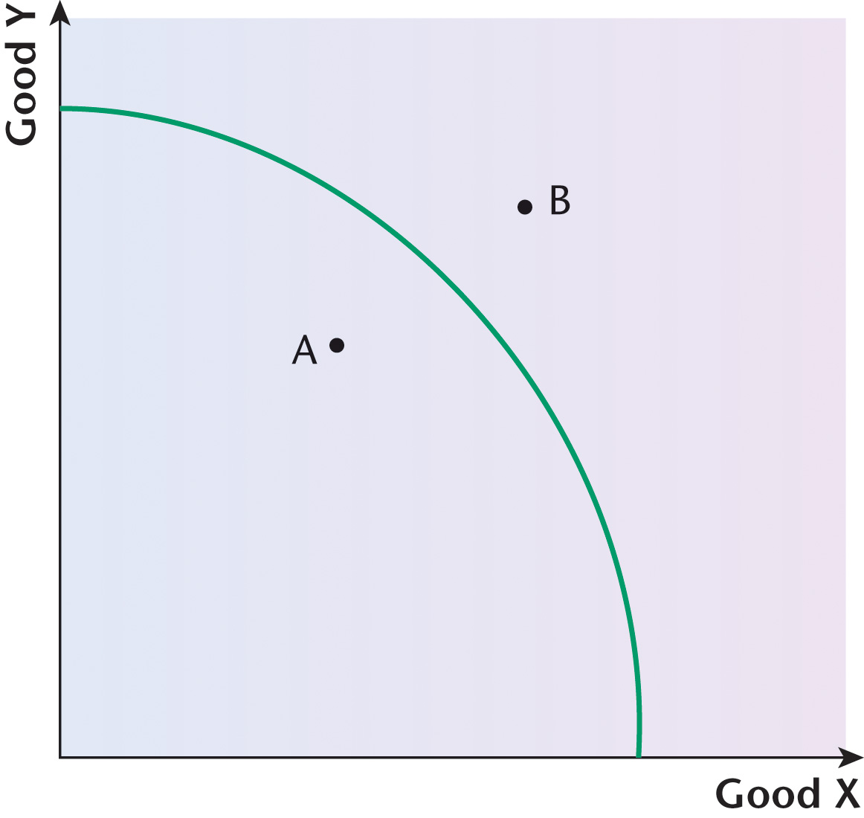
(a) Position A is inside the production possibility curve. Good X and Good Y can both be produced, but the total production is less than could be achieved at a position on the production possibility curve. This is because at any point inside the curve, not all economic resources are being fully utilised, i.e. there is some degree of unemployment of the resources which could have been used in the process of production.
(b) Position B is outside the production possibility curve. This indicates that such a combination of production of Good X and Good Y is not, at present, possible given the available resources in the economy at the present time.
12 A production possibility curve shows the combination of two products that can be produced in an economy as a result of combining the available economic resources.
If there were more resources, this would enable the production possibility curve to shift to the right. This would lead to more needs and wants being satisfied. The production possibility curve, however, only shows what can be produced at a given moment in time using the available resources. So in terms of not being able to shift to the right, it shows the condition of scarcity to a large extent.
It is possible to move along a production possibility curve by shifting resources away from the production of one good and towards the production of another. In this sense, it shows the existence of choice to a large extent as it is possible to be at any position along a production possibility curve.
However, if a decision is made to move along the curve, from one position to another, this will lead to the production of more of one good and less of another. This illustrates the implications of making a choice, producing more of one good and less of another. Such a situation focuses on the next best alternative that is forgone as a result of a movement along a production possibility curve, so the concept of opportunity cost is shown to a large extent. The only way that this would not occur is if the production possibility curve shifted to the right, making it possible to produce more of both goods.

Exam-style question
13 Student answer:
A market is often regarded as the best way to allocate scarce resources. A market provides for both producers and consumers to exercise choice: producers can decide on the combination of factors of production to be used in the production of a product and consumers can express a preference to buy or not buy the product at the market price.
The student has demonstrated an understanding of the way in which a market brings together both producers and consumers and has emphasised the importance of the expression of choice. The answer could have been developed more fully, however, such as in relation to the identification of the four factors of production that would be involved in the production process, i.e. land, labour, capital and enterprise.
It is important to use a market to allocate scarce resources because of the very existence of the condition of scarcity, given that there are infinite wants and finite resources.
It is good that the student has emphasised the importance of the concept of scarcity, but there might have been a better attempt to link this to the fundamental economic problem.
The demand curve will indicate what the consumers are willing to buy at a particular price and the supply curve will indicate what the producers are willing to sell at a particular price. The intersection of the demand and supply curves will lead to an equilibrium price and an equilibrium quantity in the market.
The student has stressed the importance of demand and supply coming together to produce an equilibrium price and an equilibrium quantity in a market, but it would have been helpful if the student had included a diagram to illustrate how market equilibrium is determined by the intersection of the demand and supply curves.
A market, however, will not always produce the ‘best’ way to allocate scarce resources. For example, a government may have given a subsidy to help the producer to reduce the costs of production and so the price charged might be lower than it would otherwise be. There is also the possibility that production has brought about a negative externality in the form of pollution, but the cost of this will not have been taken into account by the producer.
The student recognises that there are elements of market failure, such as in relation to the provision of a subsidy or the existence of pollution, but there are other aspects of market failure that might also have been considered. For example, a market is likely to lead to an overproduction and overconsumption of demerit goods, such as alcohol and tobacco, and to an underproduction and underconsumption of merit goods, such as education and healthcare. Also, a market will not be able to provide public goods where it would be virtually impossible to charge a price.
In conclusion, a market is a very efficient way to allocate scarce resources, but it is not necessarily the best way. There are a number of other factors that need to be taken into account when deciding how to allocate scarce resources.
The student does attempt to provide a conclusion, always very important in a ‘discuss’ question, but it is a rather limited and superficial conclusion that could have been developed more fully: for example, by summarising some of the other factors that might need to be taken into account.
Topic 2
Competitive markets and how they work
The nature of a competitive market
1 A competitive market refers to a situation in which a number of firms are competing against each other. There can be varying degrees of competition in different markets. For example, in perfect competition, it is assumed that there are a large number of firms competing against each other. In oligopoly, there would only be competition among a few firms, while in monopoly there is only one firm in the industry. However, from a legal point of view (in the UK a monopoly is defined as a firm with at least a 25% share of a market) there could be four firms competing against each other.
2 The term ‘optimum’ refers to the best possible situation. In terms of the best allocation of scarce resources, i.e. the factors of production of land, labour, capital and enterprise, this would be where the price of a product is equal to the marginal cost of producing the product. In this situation, allocative efficiency exists.
Demand
3
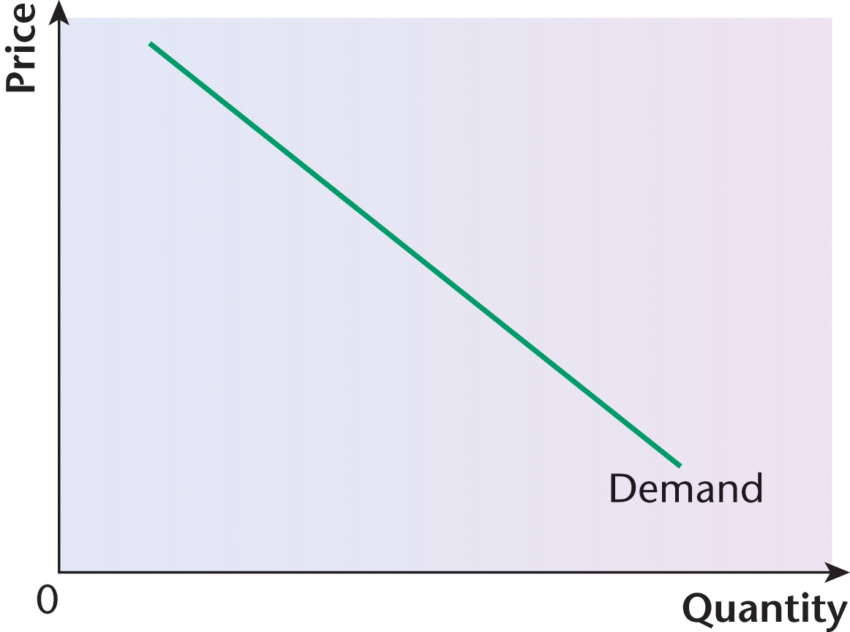
A demand curve shows the relationship between the quantity demanded and the price charged for a product. This is sometimes described as the functional relationship between the change in price of a product and a change in the quantity demanded.
It is usually downward-sloping because as the price of a product falls, people tend to buy a larger quantity. On the other hand, as the price of a product rises, people tend to buy a smaller quantity.
The concept of consumer surplus
4 The term ‘consumer surplus’ refers to the fact that individual consumers would be willing to pay particular prices for a product but, instead, the equilibrium price in a market is determined by the market demand, i.e. by all of the consumers. This means that some individual consumers pay less than they would otherwise have been willing to pay. This consumption at a lower price creates a consumer surplus.
5
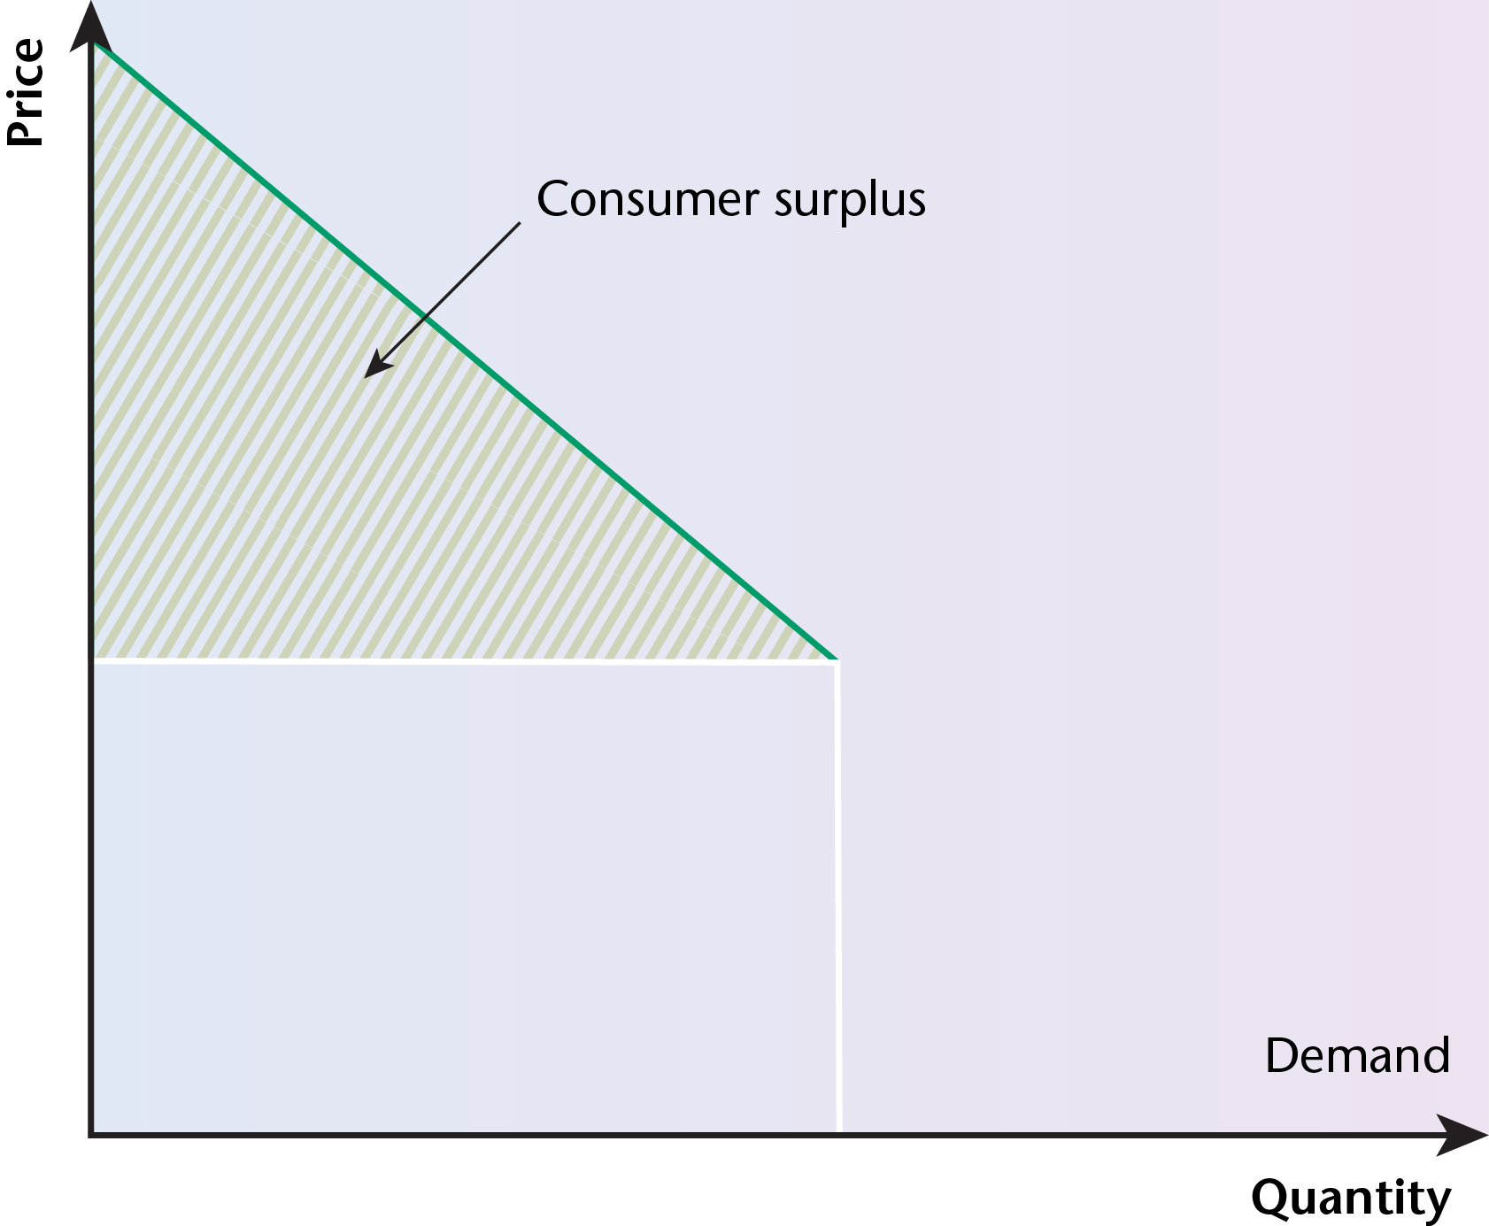
The shaded area between the horizontal price line and the demand curve is known as the consumer surplus because individual consumers would have been willing to pay more than this price. The diagram shows the equilibrium price and the equilibrium quantity. All those consumers who would have been willing to pay more were not required to do so.
Movements along, and shifts in, a demand curve
6 The term ‘ceteris paribus’ is a Latin phrase which means ‘other things being equal’. It is useful in economic theory because it allows certain aspects to remain unchanged and constant. For example, the demand for a product is determined by a number of different factors, but if economists want to isolate the influence of price on the demand for a product, ‘ceteris paribus’ can be used to indicate that all other possible influences on the demand for a product can be ignored.

Exam-style question
7 Student answer:
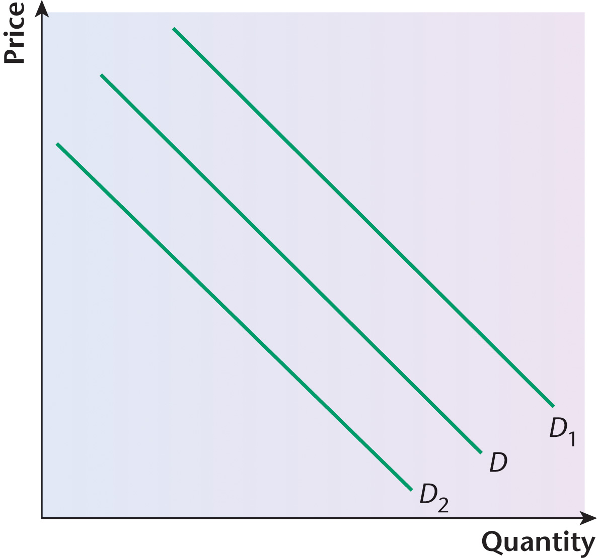
A movement along a demand curve is caused by a change in the price of a product, with all other possible influences on demand held constant. If there is a movement down the demand curve, this is known as an extension of demand. If there is a movement up the demand curve, this is known as a contraction of demand.
It is useful that the student has referred to the fact that if there is a movement along a demand curve, showing the influence of changes in the price of the product, all other influences on demand are assumed to be held constant. However, it would have been helpful if the student had pointed out that this is known as the ‘ceteris paribus’ assumption.
If, however, the other possible influences on the demand for a product can now be taken into account, such as changes in income or changes in the prices of other products, these changes can lead to an increase in the demand for a product. In this case, the demand curve shifts to the right. If these changes lead to a decrease in the demand for a product, the demand curve shifts to the left.
The student clearly understands the difference between the influence of the price of a product on demand and the other possible influences, recognising the difference between a movement along a demand curve and a complete shift of the curve, either to the left or to the right. Although a diagram is included, the student could have integrated the diagram into the analysis to support the points made.
Supply
8
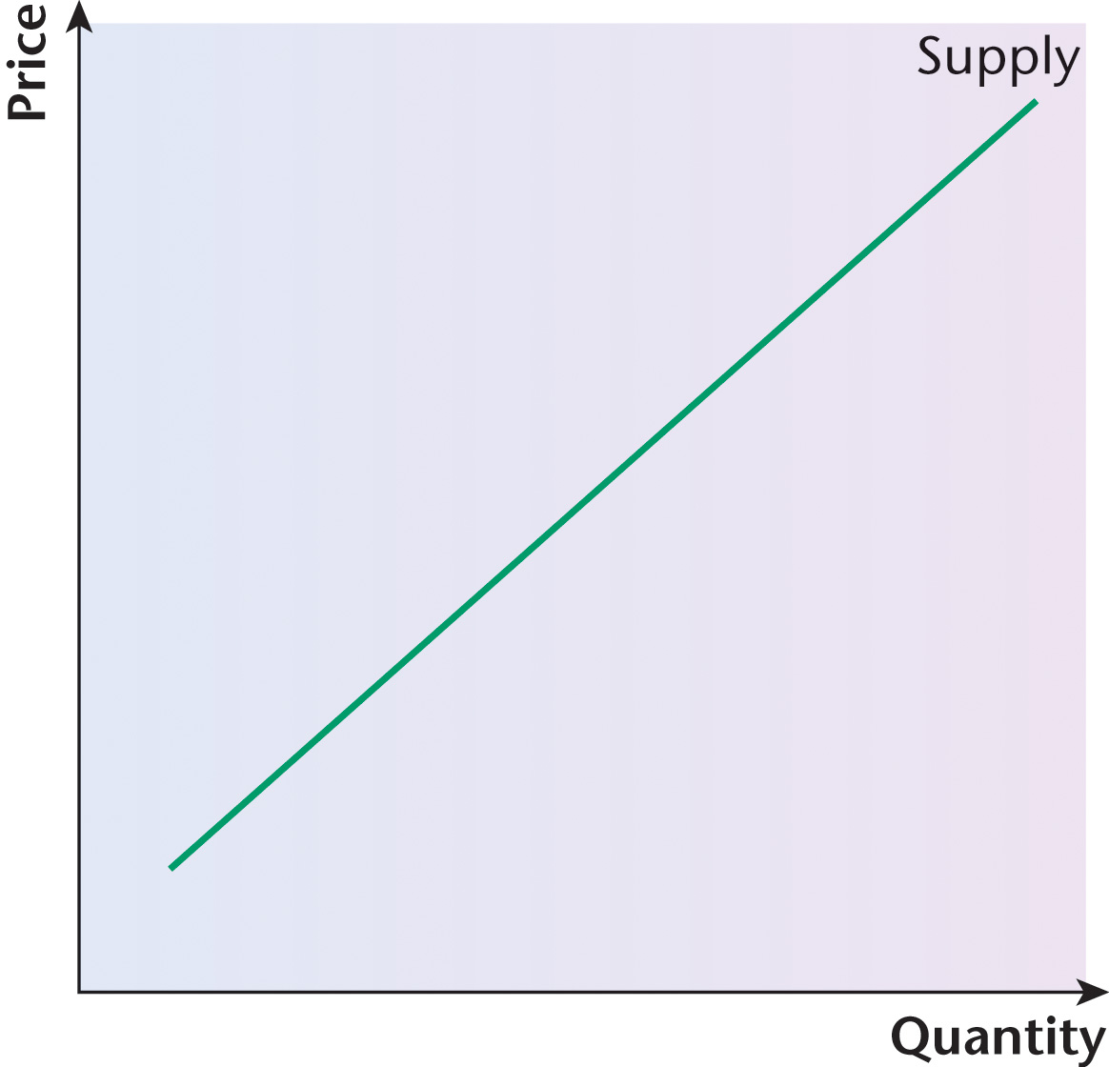
A supply curve shows the relationship between changes in the price of a product and changes in the supply of that product. As can be seen in the diagram, the supply curve is usually upward-sloping because a higher price is likely to give a producer the incentive to produce more. The supply curve is actually the marginal cost of production and so if the cost of producing one more product goes up, the firm will also want the price to go up.
The concept of producer surplus
9 Different producers would be willing to accept various prices for a product before deciding to sell it, but the equilibrium price in a market is a reflection of market demand and market supply. The extra money received by some firms, above what they would have been otherwise willing to accept, is known as the producer surplus.
10
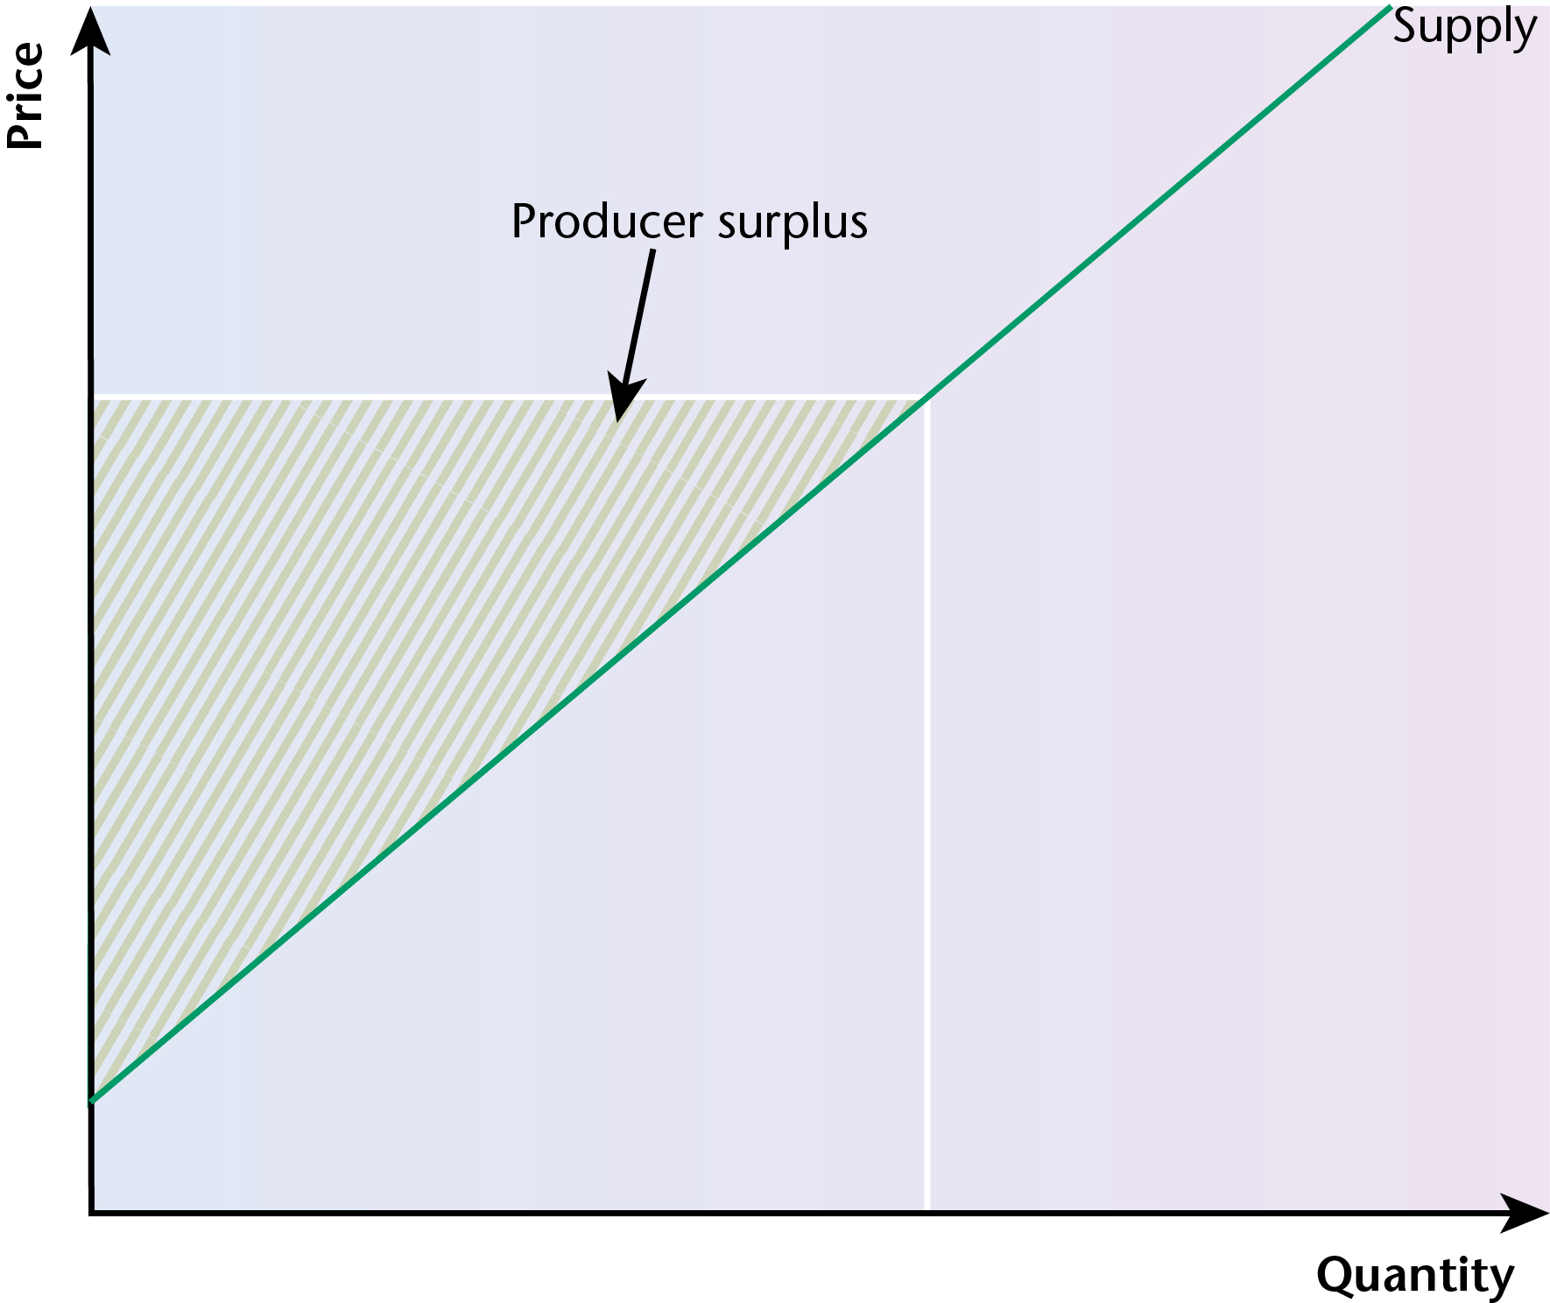
In the diagram, the producer surplus is shown by the shaded area between the horizontal price line and the supply curve. Individual producers would have been willing to accept a lower price, but the equilibrium price is determined by the intersection of market demand and market supply. Producer surplus, therefore, is the additional amount received by producers who would have been willing to supply a product at a lower price.
Movements along, and shifts in, a supply curve

Exam-style question
11 (a) Student answer:
A supply curve could shift to the right as a result of changes that are favourable to the supply of a product. For example, a reduction in the costs of production, such as raw materials or component parts, would lower the cost of production and this would be likely to cause an increase in the level of production. A development in technology might also encourage firms to produce more. The provision of a subsidy by a government would also have the effect of lowering the costs of production, causing the supply curve to shift to the right.
The student correctly recognises that a lowering of the costs of production would be favourable to the supply of a product, causing the supply curve to shift to the right. There is a reference to the possible influence of a development in technology, but it would have been helpful to include an example of such a development to support the point being made. One possible example would be the use of robotic welders in car factories. The student correctly recognises the importance of the provision of a subsidy, but examples of such situations might have been given, such as essential foodstuffs. The student might also have referred to factors relevant to agricultural production, such as favourable weather conditions.
(b) Student answer:
On the other hand, a leftward shift of a supply curve would come about as a result of changes that are not favourable to the supply of a product. For example, the imposition of an indirect tax would cause supply to shift to the left. In the production of agricultural products, adverse weather conditions would be likely to shift the supply curve to the left.
The student recognises that the imposition of an indirect tax would cause supply to shift to the left, but the student could have included appropriate examples of products to suggest where and when an indirect tax might be imposed, such as in relation to demerit goods, e.g. alcohol and tobacco. There was no reference to agricultural production in terms of a rightward shift of a supply curve, but it is brought in here in relation to a leftward shift of the supply curve.
Market equilibrium

Exam-style question
12 Student answer:
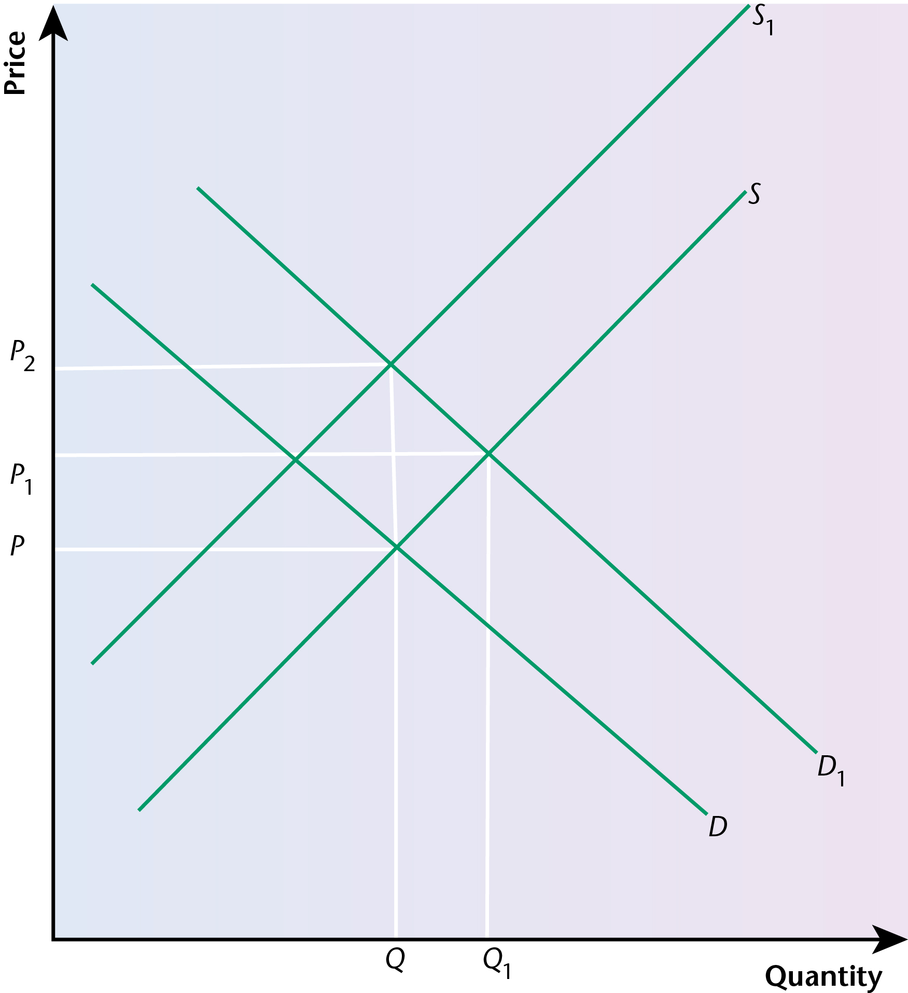
The equilibrium in any market, such as the housing market, is determined by the forces of demand and supply. Any changes in the demand and/or supply conditions could bring about a change in the equilibrium.
This is a useful first paragraph that sets the scene, although there could have been more of an attempt to integrate the diagram into the answer.
A reduction in unemployment will mean that more people are working and earning incomes, so demand is likely to rise. This would be shown by a shift of the demand curve to the right. Similarly, an increase in real wages means that wages rise by more than the rate of inflation. This would also have the effect of shifting the demand curve to the right.
The student recognises that both of these changes would cause the demand curve to shift to the right, but again the changes shown in the diagram could have been brought into the answer.
Whereas the first two bullet points were concerned with changes in demand factors, the last two bullet points are concerned with supply factors. A reduction in the number of building firms would cause the supply curve to shift to the left. Similarly, adverse weather conditions over a prolonged period of time would make it difficult to build houses, so again the supply curve would shift to the left.
The diagram shows that in this situation, the two shifts would cause an increase in the equilibrium price in the housing market. The effect on the equilibrium quantity is less certain and would depend on which of the two shifts was more powerful.
The student recognises that the last two bullet points, in contrast with the first two, are related to the supply side and would cause the supply curve to shift to the left. The explanation of the effect on price is clear, but more could have been written on the effect on the equilibrium quantity in the market. Again, there could have been more of an attempt to link the answer to what was shown in the diagram.
Price, income and cross elasticity of demand
13 Elasticity refers to the degree of responsiveness, or the level of sensitivity, to a change in a variable, such as the price of a good, the price of another good or income.
14 Price elasticity of demand refers to the responsiveness of the quantity demanded of a product to a change in its price. It is calculated by dividing the percentage change in the demand for a product by the percentage change in its price. Its value can range from 0 to infinity. If the value of PED is 0, then the PED is perfectly inelastic. If the value of PED is between 0 and 1, then the PED is inelastic. If the value of PED is equal to 1, then the PED is unitary elastic. If the value of PED is between 1 and infinity, then the PED is elastic. If the value of PED is infinity, then the PED is perfectly elastic.
15 The concept of price elasticity of demand is extremely relevant to a business in terms of helping the business to increase its total revenue.
If the price elasticity of demand for a product is elastic, this means that the demand is very responsive to a change in the price of the product. In this situation, it would be better for the business to lower the price of the product. Although this means that less revenue will be coming in for each item sold, this will be offset by the increase in the number of units sold.
If the price elasticity of demand for a product is inelastic, this means that the demand is not very responsive to a change in the price of the product. In this situation, it would be better for the business to increase the price of the product. Although this will lead to fewer units being sold, this will be offset by the increase in the price of each unit sold.
16 Income elasticity of demand refers to the relative change in the demand for a product in relation to a change in income. It is calculated by dividing the percentage change in the quantity demanded of a product by the percentage change in income.
In most cases, the income elasticity of demand for a product is positive, i.e. as incomes rise, so does the demand for goods and services. These are known as normal goods.
However, in some cases, the income elasticity of demand for a product is negative, i.e. as incomes rise, there is a fall in the demand for certain goods and services. These are known as inferior goods. Examples could include bicycles if people are better able to afford motor cars.

Exam-style question
17 Student answer:
Income elasticity of demand refers to the responsiveness of the quantity demanded of a product to a change in the level of incomes. It is calculated by dividing the percentage change in the quantity demanded of a product by the percentage change in income. In most cases, it is positive and this is the situation with normal goods. In some cases, however, it is negative and this is the situation with inferior goods.
The first paragraph is clear in defining what is meant by the concept of income elasticity of demand and in explaining the distinction between normal and inferior goods.
If an economy is facing a rise in unemployment, assuming that the benefits paid to people who become unemployed are less than the income previously received by the workers, then there will be a fall in the general level of people’s incomes. The extent of this fall in an economy will depend on the number of people who become unemployed and the difference between what they were previously receiving and what they are now receiving while unemployed.
It would have been useful if the student had referred to net income in stressing the extent of the difference in income. The student does appreciate, however, that in order to measure the difference in income, it will be necessary to take into account the value of the transfer payments paid to those people who have become unemployed.
If this was the case, then a business could expect to experience a fall in the demand for some normal goods and an increase in the demand for some inferior goods. Different businesses could react to this in different ways. For example, a supermarket might decide to sell fewer luxury ‘top of the range’ products and more cheaper and basic items, such as ‘own brand’ products. Similarly, an electrical store might decide to sell more basic models of televisions rather than the more expensive models or it might decide to increase the number of models that can be rented rather than purchased.
This is useful in supporting the analysis. It always helps to include examples to support the points being made. These are appropriate examples to use, especially the ‘own brand’ basic foods.
It can be seen, therefore, that a business could use the concept of income elasticity of demand to good effect in an economy which is facing a rise in unemployment.
The student attempts to offer a conclusion as a way of bringing the analysis to an end, but it would have been clearer if there had been an explicit reference to inferior goods.
18 Cross elasticity of demand refers to the relationship between the demand for one product and the change in price of another product. It is calculated by dividing the percentage change in the quantity demanded of Product A by the percentage change in the price of Product B.
The relationship can be positive or negative, depending on whether the two goods are substitutes or complements.
If the two goods are substitutes, say tea and coffee, then the cross elasticity of demand will be positive.
If the two goods are complements, say DVDs and DVD players, then the cross elasticity of demand will be negative.
19 The concept of cross elasticity of demand could be of great relevance to a business. For example, if a firm produces tea and there is a substantial increase in the price of coffee, the cross elasticity of demand will be positive. The tea producer will expect there to be a decrease in the demand for coffee as a result of the increase in the price of that product. The extent of the decrease in demand for coffee as a result of the price increase will depend on the price elasticity of demand for the product. If tea is seen as an effective substitute for coffee, then the price elasticity of demand for coffee is likely to be quite elastic. The tea producer, therefore, can plan to produce more tea in the expectation that demand for the product will increase, leading to an increase in revenue and profit.
If two products are complements, and are consumed together, the situation is different. Petrol (or diesel) and motor cars are complements — if you have a car, you will need either petrol or diesel to put in it. If there is a substantial increase in the price of petrol or diesel, this is likely to reduce the demand for the fuel and this could consequently lead to a decrease in the demand for motor cars. The extent of the response to the rise in the price of fuel will depend on the price elasticity of demand for it. A producer of motor cars may decide, therefore, to plan for less production. Alternatively, it may anticipate a move away from cars which consume a lot of fuel towards more fuel-efficient cars, and it will plan, therefore, to alter production plans to produce more fuel-efficient cars. This will especially be the case if the rise in the price of fuel is expected to be long-term.

Exam-style question
20 Student answer:
Price elasticity of demand is potentially of great relevance to a business. It gives an indication of the link between changes in the price of a good and changes in demand. If a business owner knows whether the demand for a good is price elastic or price inelastic, it will inform a decision as to whether to increase or decrease price in order to raise revenue.
This demonstrates that the student understands the link between a change in the price of a good and the change in demand, but the link could have been defined more clearly, i.e. price elasticity of demand is the percentage change in the quantity demanded of a product divided by the percentage change in the price of the product. The link between change in price and change in revenue is made, but the student needed to go much further on this: for example, by pointing out that if the demand for a good is price elastic, its price should be reduced to increase revenue, but if the demand for a good is price inelastic, its price should be increased to raise revenue. Appropriate diagrams could have been included to illustrate this.
Although the price elasticity of demand for a product is very important to a business, the other two types of elasticity are also potentially important. The income elasticity of demand shows the link between the demand for a product and changes in income. Knowledge of changes in income in an economy can help a producer decide which products to sell.
Again, the student demonstrates knowledge and understanding of the link between changes in income and changes in demand for a product, but it would have been helpful if the concept had been defined more clearly, i.e. it is the percentage change in the quantity demanded of a product divided by the percentage change in income. The student should also have made clear the distinction between the demand for normal and for inferior goods. If it is a normal good, the income elasticity of demand is positive, i.e. when there is an increase in income, there is an increase in the demand for a normal good. If it is an inferior good, the income elasticity of demand is negative, i.e. when there is an increase in income, there is a decrease in the demand for an inferior good. The last sentence also needs to be developed more fully, e.g. if incomes are generally rising in an economy, a producer should plan to produce more normal goods and fewer inferior goods, whereas if incomes are generally falling in an economy, a producer should plan to produce fewer normal goods and more inferior goods.
Cross elasticity of demand is also potentially of great relevance to a business. This shows the link between changes in the demand for one good and changes in the price of another good. These goods can either be substitutes or complements. A business would be keen to know about changes in the prices of other products and how such changes would affect the demand for its own products.
The student understands that cross elasticity of demand is concerned with the link between the change in demand for one product and the change in the price of another product. This could have been more clearly defined in terms of the percentage change in the demand of Product A divided by the percentage change in the price of Product B. The student appreciates that goods can be either substitutes or complements, but this needed to be discussed more fully, e.g. by pointing out that the cross elasticity of demand for substitutes will be positive whereas the cross elasticity of demand for complements will be negative. The last sentence is rather superficial. It would have been helpful if the student had used examples of substitutes and complements to support the point being made. For example, a coffee producer will plan to produce more coffee if the price of tea rises significantly, because some consumers will switch from the consumption of tea to the consumption of coffee as a result of the substantial rise in the price of tea, since coffee and tea are substitutes. On the other hand, a producer of DVD players will plan to produce more of these if the price of DVDs falls significantly, because consumers will be likely to increase their demand for DVDs as a result of the fall in their price and so the demand for DVD players will increase, as DVDs and DVD players are complements.
In conclusion, all three types of elasticity are potentially of great importance to a business.
It is always good in a ‘discuss’ question to end with a conclusion, but in this case the conclusion does not go very far. A key phrase in the question is ‘more relevance’, and the student has not addressed the issue of whether price elasticity of demand is of more relevance to a business than the other two. If the student thought that all three were of equal relevance to a business, this should have been made clear, along with the reasons and the justification to support this conclusion.
Elasticity of supply
21 Elasticity of supply refers to the degree of responsiveness of a change in the supply of a product to the change in the price of the product. The value of elasticity of supply can vary from zero, when it is perfectly inelastic, to infinity, when it is perfectly elastic. If it is perfectly inelastic, the supply curve will be vertical. If it is perfectly elastic, the supply curve will be horizontal.
The value of elasticity of supply will vary over a period of time. In the short run, when at least one factor of production is fixed, supply will be relatively inelastic. However, in the long run, when all factors of production are variable, it becomes easier to change supply and so the elasticity of supply becomes more elastic.

Exam-style question
22 Student answer:
Elasticity of supply measures the responsiveness of the change in the quantity supplied to a change in the price of a product. It is calculated by dividing the percentage change in the quantity supplied by the percentage change in the price of a product.
This is a useful introductory paragraph. It introduces the concept of elasticity of supply and explains how it can be calculated.
In the short run, at least one factor of production will be fixed. In this situation, even if there is a substantial increase in the price of a product, it may not be easy to substantially increase supply in response to this price change. Of course, if there are unsold stocks that can be released on to the market fairly quickly, this will make supply more elastic than it would otherwise have been.
The student links the extent of supply elasticity to a period of time, pointing out that in the short run at least one factor of production will be fixed and that this will, therefore, limit the extent of the elasticity. A useful point is made in relation to the possible existence of unsold stocks, although this point could have been developed more fully, such as in terms of a contrast between manufactured and agricultural products — it is generally much easier to store manufactured goods over a period of time than agricultural goods. There are also questions about storage space and costs that could have been brought into the analysis.
In the long run, all factors of production become variable and so it becomes easier to adjust supply to the change in the price of a product. A greater number of resources can be allocated to the production of the product and so, in the long run, supply will become more elastic.
The student moves on to the long run, pointing out that in this situation, all factors of production become variable and so supply can more easily respond to any change in price, i.e. supply becomes more elastic. Again, a contrast might have been made between manufactured goods and agricultural goods. The length of time taken to grow crops will usually be longer than would be the case with the production of manufactured goods.
In conclusion, supply is likely to be more elastic over a period of time because as all factors of production become variable, it is possible to allocate resources accordingly to take account of the change in price of the product.
This is a useful conclusion, but again a contrast might have been made between manufactured and agricultural products.
Allocative efficiency
23 Allocative efficiency refers to a situation in an economy when the scarce resources are allocated in such a way that the resources are valued equally by both the producers and the consumers. This occurs when the marginal cost of production is equal to the price of the product produced.
Topic 3
Market failure and government intervention
The meaning and nature of market failure
1 Market failure refers to a situation in an economy where there is an inefficient, or sub-optimal, allocation of scarce resources. This occurs because of the existence of a variety of different possible forms of market imperfection. For example, some goods might be over-produced and over-consumed — demerit goods. Some goods might be under-produced and under-consumed — merit goods. Some goods might not be provided at all in a market, without any government intervention — public goods. Some markets might not be competitive and may be dominated by just one firm, as in the case of a monopoly. Firms may only take into account private costs and benefits, and not the possible external costs and benefits, giving rise to the existence of externalities. Some decisions may be based on insufficient knowledge about the implications of taking certain decisions, a situation known as information failure.
Market failure, therefore, is a collective term for all those imperfections in an economy where resources are not being allocated in the best and most efficient way.
Private and social costs and benefits
2 The term ‘third party’ refers to those people who are not directly involved in the production process, but who are still affected by it. This is why it is often linked with the idea of a ‘spillover effect’.
3 A social cost takes into account the full cost to a society or community of a production process. This means that it includes both the private cost, which is the internal cost of production to a firm, such as wages and raw materials, and the external cost to the society, which might be the impact of pollution or congestion in the area.
Social cost is important because it emphasises the full cost of the resources used in the production process, including costs that are both internal and external to the production process.
4 An external benefit is one that comes about as a result of production. It benefits someone who is a third party and, therefore, not directly involved in the production process. In this sense, there is a positive ‘spillover effect’.
An example could be the benefits that arise from a factory being built in an area, employing many workers. These workers receive payment. They will spend some of this money in the area in a variety of shops, restaurants and petrol stations. This extra spending benefits the people who work in these shops, restaurants and petrol stations and so this is an external benefit to them of the workers being employed in the factory.
Negative and positive externalities

Exam-style question
5 Student answer:
An externality is where there is a positive or negative effect on a community as a result of the production process. The existence of an externality means that there is not allocative efficiency.
The student makes it clear that an externality can be either positive or negative and links this with the concept of allocative efficiency.
A negative externality occurs when there is a divergence between private costs and social costs. A firm will only take into account the private cost of production, but there are likely to be side effects of this production on the community, known as a ‘spillover effect’. This private cost to the firm does not take into account the costs created as a result of the effect of the production in the community. These are the external, as opposed to the internal, costs of production. There is, therefore, market failure because the true value of the costs to the community have not been expressed. These would be the social costs of production because these take into account both the private and the external costs.
This section focuses on the existence of a negative externality. There is a clear contrast between private and external costs, although there could have been an explicit reference to ‘third party’ effects. The student could also have provided an appropriate example of a negative externality.
In a similar way, a positive externality can exist as a result of the production process. This occurs when there is a divergence between private benefits and social benefits. There will clearly be private benefits of production, such as the wages paid to the workers and the profit made by the firm, but there may also be additional benefits that affect the community. For example, some of the wages that are earned by the workers will be spent in the local community and this could contribute to an increase in the revenue and profit of local firms. The private benefit alone would, therefore, not give a true picture of the full value of the production process. The social benefit, however, would represent the true value of this because it would take into account both private and external benefits of production.
This section focuses on the existence of a positive externality. The divergence between private benefits and social benefits is made clear. The student gives a useful example to illustrate the existence of a positive externality.
In conclusion, externalities, both positive and negative, can lead to market failure in an economy because the true cost of production is not being taken into account unless social costs and social benefits are used to represent the value of the production process.
The student could have made the link between externalities and sub-optimal allocative efficiency in an economy more clearly.
Information failure
6 Information failure refers to a situation where decisions are taken in an economy by some people who do not have all the information necessary to make rational and well-informed decisions. For example, some products may be under-consumed or over-consumed because some people do not fully appreciate the positive or negative effects of taking certain decisions.
7 Information failure refers to a situation where decisions that are taken by some people in an economy are not based on all the necessary information required to make an informed judgement.
Information failure can lead to market failure because as a result of it some products will be under-consumed while others will be over-consumed.
In the case of under-consumption, this is because some consumers do not fully appreciate the potential worth of consuming certain products. These are known as merit goods and examples include education and healthcare. As a result of information failure, some consumers will under-value the worth of such consumption, creating a market failure.
In the case of over-consumption, this is because some consumers do not appreciate the possible negative side effects of consuming certain products, such as alcohol and tobacco. As a result of information failure, some consumers do not realise the potential negative effect of the consumption of such products on their health, creating a market failure.
Merit, demerit and public goods
8 A merit good is one which is generally regarded as being of merit or value and yet there is the possibility that many people will undervalue its consumption, leading to market failure. A merit good, such as education or healthcare, will benefit people throughout their lives and this is why governments in many countries support their provision. A merit good is a private good and, like all private goods, is both rival and excludable in consumption.

Exam-style question
9 Student answer:
A merit good is a product that has some intrinsic value or worth which could be under-estimated by some people in a society. It is generally seen as socially desirable, but there could be under-production and under-consumption of such a good.
The student begins by providing a clear explanation of what a merit good is. The student could have developed this point further, however, by bringing in the concept of market failure in relation to the possible existence of under-production and under-consumption.
A museum is a good example of a merit good. There are many different kinds of museum in a society that people could visit, covering such areas of interest as history, geography, geology, archaeology, music, transport and art. The underlying idea of a merit good is that the consumption of such a good has some form of worthwhile value and a museum would be a good example of this. Museums are extremely informative and people benefit a great deal from visiting one.
The case is clearly put for regarding a museum as an example of a merit good, giving some indication of how people could benefit from visiting one.
However, if an entrance fee was charged, it is possible that many potential consumers would not pay to go into a museum because they would not think that it was worthwhile to pay the fee. In terms of opportunity cost, they would need to consider the possible alternative products that they could spend their money on.
This section addresses the possible existence of under-consumption if an entrance fee were charged. It links this to the concept of opportunity cost and the idea of possible alternatives being forgone.
It is for this reason that, in many countries, the government decides either to abolish entrance fees and make museums free, or to provide a subsidy to keep the entrance fee lower than it would otherwise be.
The first example is valid if a museum is in the public sector, but a museum is an example of a private good and some museums will be in the private sector. In such a situation, there is not much that a government could do. The second example, however, could apply to both the private and the public sector. The consideration of the effect of a subsidy could have been developed further by explaining more fully how the provision of a subsidy would shift the supply curve to the right, reducing the equilibrium price. A diagram could have been included to show this impact.
In conclusion, it should be clear that museums can be regarded as a merit good to a very large extent.
The conclusion could have been developed more fully, in relation to market failure and the need for government intervention, for example.
10 A demerit good is an example of market failure in that it is a private good which could be over-produced and over-consumed in a market.
There is something potentially negative about the consumption of a demerit good, such as in relation to possible damage to a person’s health and general wellbeing. Alcohol and cigarettes are often given as examples of a demerit good because excessive consumption of either (or both) of these products could be damaging to a person’s health.
This is why, in many countries, there is information on such products warning people of the consequences of consuming them. For example, in the case of cigarettes, packets may contain a warning such as ‘smoking can kill’. This is an example of where a government has intervened to overcome information failure.

Exam-style question
11 Student answer:
A private good is one which is bought by individuals for their own benefit, such as food and clothing. Private goods are rival and excludable in consumption, i.e. once consumed by one person, they cannot be consumed by another. Other potential consumers are excluded from consumption. They are rival in that different consumers are competing with each other to buy the private goods that are needed to satisfy their needs and wants.
The student offers a clear explanation of the meaning of private goods, in being rival and excludable, and gives a couple of examples of them.
A public good, on the other hand, is very different from a private good. Public goods are both non-rival and non-excludable in consumption, i.e. no one is excluded from benefiting from a public good and there is no rivalry in consumption.
The contrast with public goods is made clear, especially in terms of them being both non-rival and non-excludable.
A public good is provided through the public sector because it would be very difficult, if not impossible, to charge for the consumption of them. Examples include street lighting, national defence and the operation of the police force. It would be impossible to provide them through the private sector because it would be impossible to exclude those who had not paid.
Some appropriate examples of public goods are provided. There is a reference to the difficulty of charging a price for them in the private sector, but this could have been developed more fully, such as in relation to the existence of ‘free riders’.
There are, therefore, clear differences between a private good and a public good.
This is a rather superficial conclusion. It would have been better to devlop it more fully by referring to the key differences between them, especially in relation to the fact that private goods are rival and excludable whereas public goods are non-rival and non-excludable.
Government intervention to correct market failure
12 Education and healthcare are both examples of merit goods, i.e. the consumption of them has some intrinsic merit, value or worth and yet there is the possibility that they could be under-produced and under-consumed in a market.
They are, however, private goods, not public goods. Therefore they will not be provided exclusively through the public sector, as would be the case with, say, police or national defence.
They are, therefore, provided through both the private sector and the public sector. Just like any private good, such as food and clothing, they can be given a market price and people can pay this price for education and healthcare if they so wish.
The problem, however, is that if a market price is charged, some consumers will be unwilling or unable to pay this price. A government may decide that as education and healthcare are examples of merit goods, they need to be provided through the public sector as well, operating alongside provision in the private sector.
13 An indirect tax is taken out of expenditure. It is usually included in the price of goods and services that are being purchased. Examples include value added tax (VAT), goods and services tax (GST) and excise duty.

Exam-style question
14 Student answer:
An indirect tax is an expenditure tax, i.e. it is a tax that is placed on goods and services when they are being purchased. Examples include VAT and excise duties.
The answer begins with a useful explanation of what an indirect tax is and gives some appropriate examples.
A government could decide to impose an equal amount of indirect tax on every product purchased in an economy. This would be fair in the sense that every product is treated equally. However, governments usually decide to place different rates of tax on various products.
The student introduces the idea that there is differential taxation on various products.
One example of this would be fuel. In the UK, over 70% of the price of diesel or petrol is tax. Governments impose such a high rate of tax on fuel to discourage consumption. Fuel is a finite resource and will eventually run out, so governments tax it at a high rate to make people think twice before purchasing it. Governments also know that the demand for fuel is extremely price inelastic and so, if tax is increased on it, the effect on demand will be minimal. It is, therefore, a useful source of revenue for the government.
The student gives an appropriate example of a product which carries a relatively high rate of indirect tax. There is also a useful link with the concept of price elasticity of demand, although this concept could have been explained more fully. It would have been helpful to link the final sentence of this section to fiscal policy.
Another example of products having a higher rate of tax imposed on them than other products relates to the purchase of demerit goods. The price of alcohol and tobacco in the UK includes over 70% of tax. Governments know that without such high taxation, the consumption of such products would probably increase significantly, causing a range of harmful effects on people consuming them. As with petrol and diesel, the demand for such addictive products is very price inelastic.
Another example is given to support the analysis, although there could have been a clearer explanation of what is meant by a demerit good. The student could also have made a fuller link with elasticity in the final sentence.
However, in many countries, governments decide to tax other products at lower than average rates or not tax them at all. For example, in the UK, most items of food are not taxed. Although items of clothing are taxed, children’s clothing is exempt from taxation. Fuel bills are taxed at a VAT rate of only 5% compared to 20% on most goods and services.
The student gives some interesting examples of products that are taxed at lower rates or not taxed at all. This helps to give a balanced approach to the analysis.
It can therefore be seen that while some items in an economy are taxed at higher rates, there are lower rates on other products, and no tax at all is imposed on some.
It would have been useful if the conclusion had been more clearly linked to the concept of fairness as this is a key part of the question. For example, the student could have considered what is meant by fairness, especially in relation to normative, as opposed to positive, economics.
15 A subsidy is a payment, usually made by a government, to a producer in order to keep down the costs of production borne by the producer. In this way, it should be possible for a lower price to be charged than would otherwise have been the case. It is shown in a demand and supply diagram by a rightward shift of the supply curve, leading to a lower equilibrium price and a greater equilibrium quantity.

Exam-style question
16 (a) Student answer:
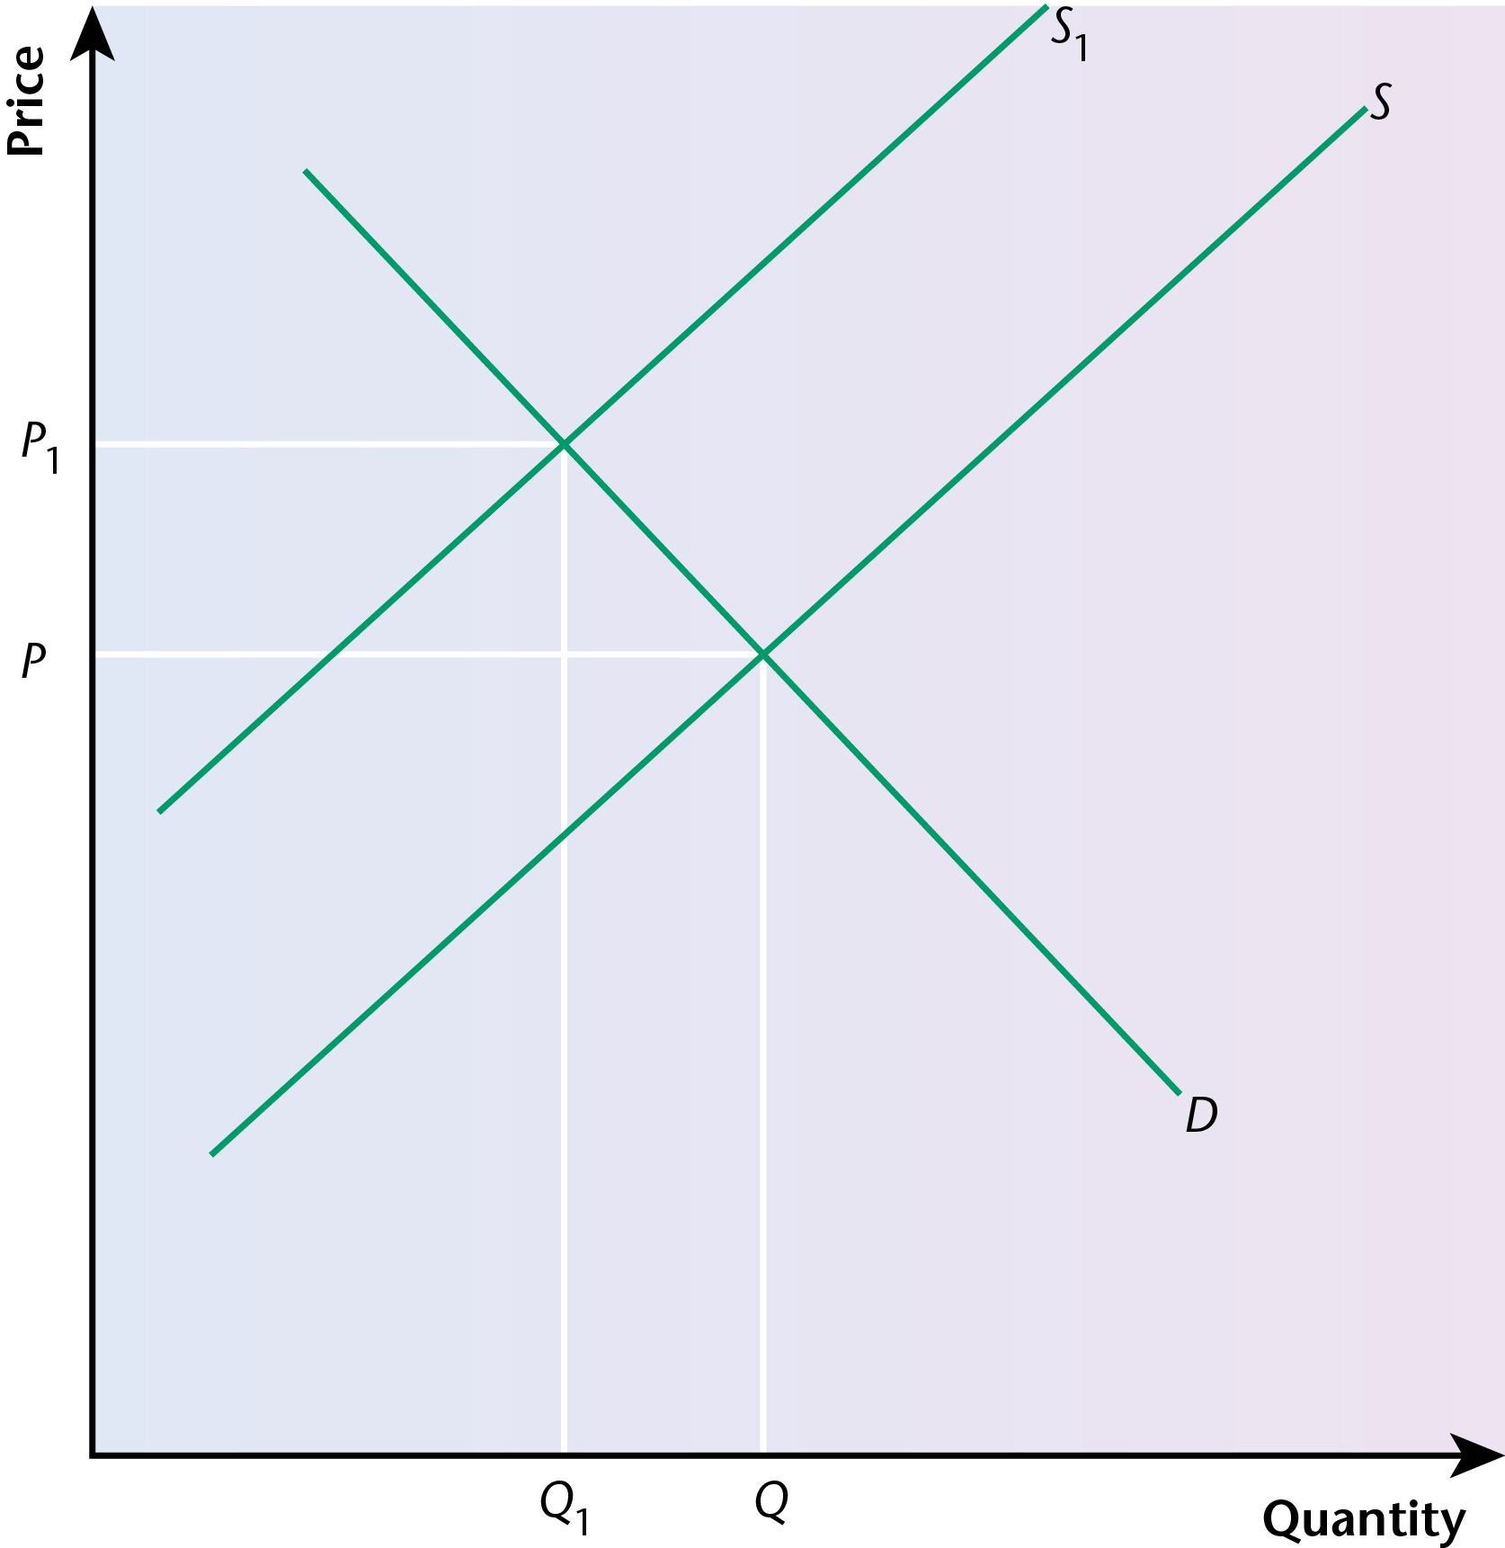
The above diagram shows the impact of the imposition of an indirect tax on the equilibrium price and the equilibrium quantity of a good in a market. The supply curve shifts to the left, causing an increase in the equilibrium price and a reduction in the equilibrium quantity.
(b) Student answer:
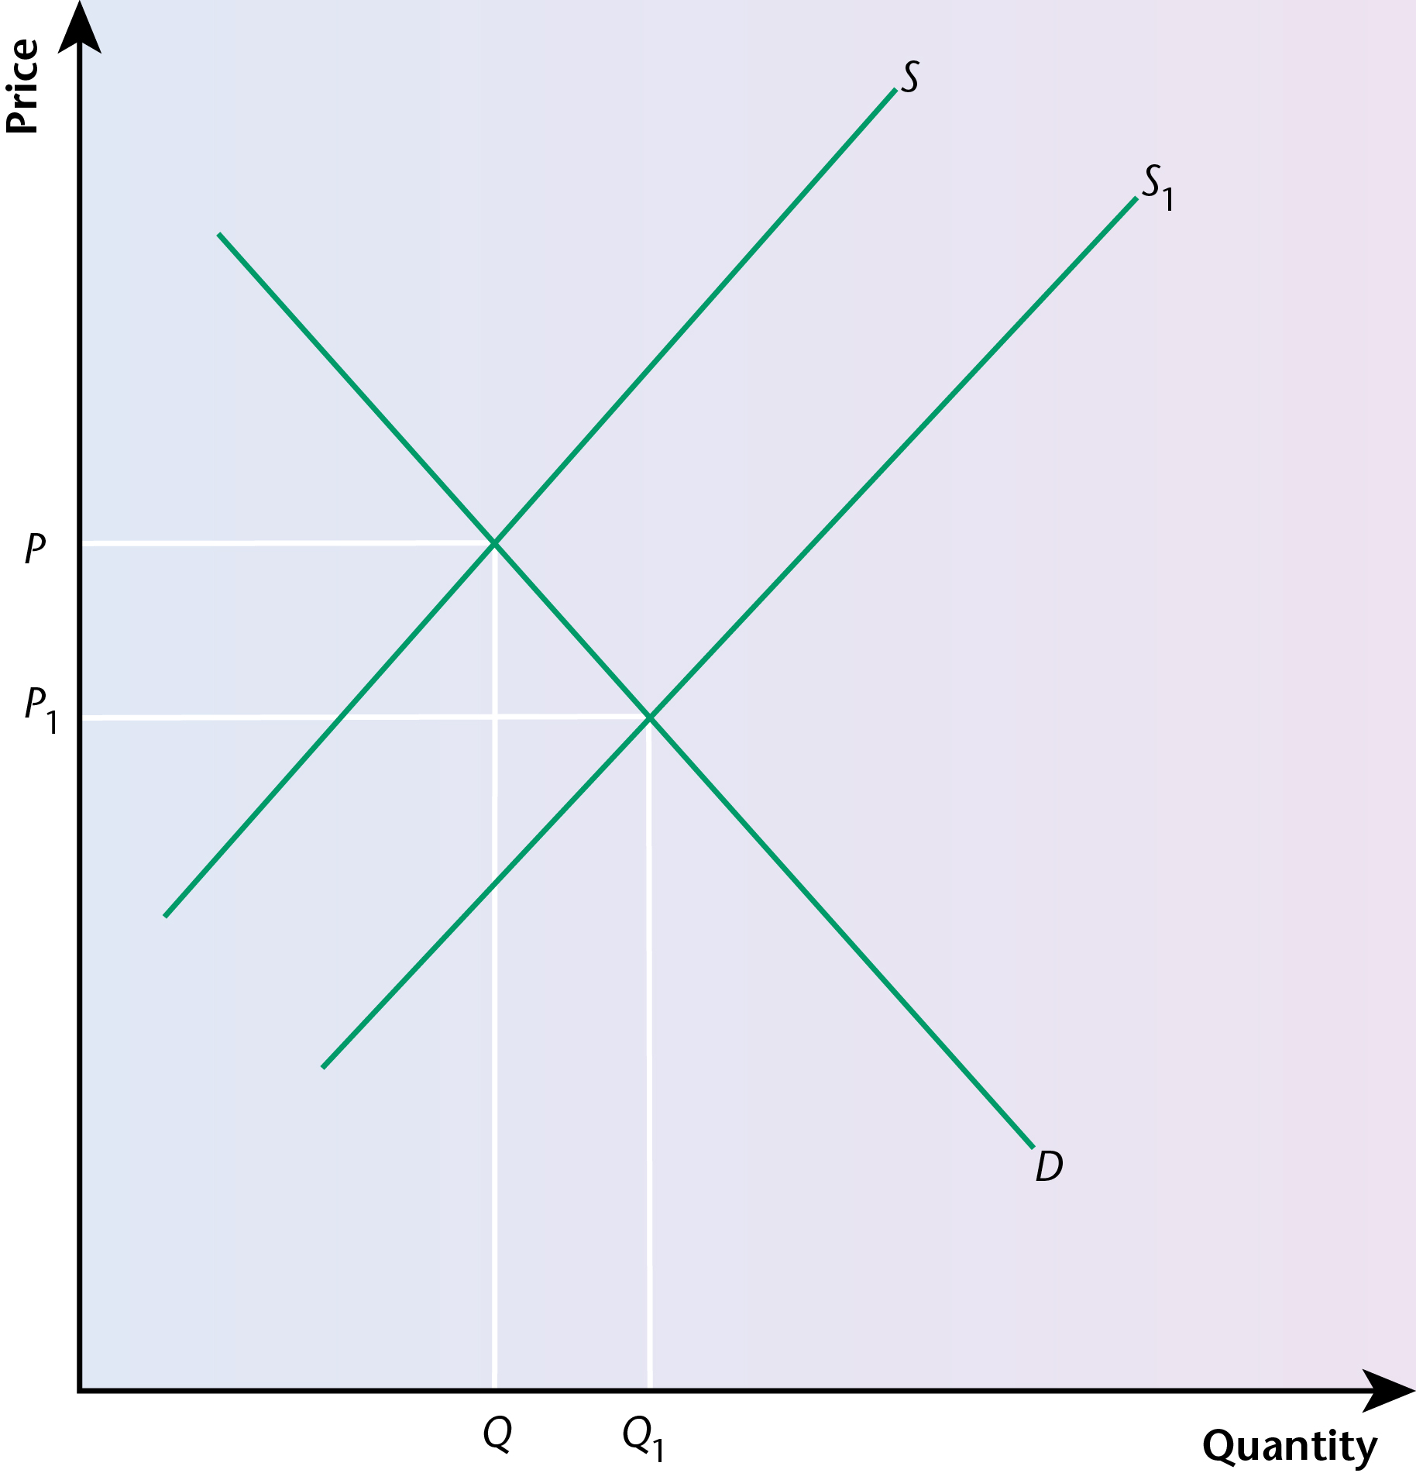
The above diagram shows the impact of the provision of a subsidy on the equilibrium price and the equilibrium quantity of a good in a market. The supply curve shifts to the right, causing a decrease in the equilibrium price and an increase in the equilibrium quantity.
17 A variety of regulations and laws can be used to reduce the extent of market failure in an economy.
For example, a government could pass a variety of consumer protection laws to give consumers more power. In the UK, these include the Trade Descriptions Act, the Weights and Measures Act, the Consumer Credit Act, the Sale of Goods Act and the Consumer Protection Act.
Regulations could also apply to the degree of competition in a market, especially in terms of restricting the power of monopolies. In the UK, these include the Fair Trading Act, the Restrictive Trade Practices Act and the Competition Act.
Regulations could be brought in to try to control the extent of pollution in an economy. In the UK, these include the Clean Air Act.
All these regulations are designed to reduce the extent of imperfections in markets and so reduce the extent of market failure, bringing about a greater degree of allocative efficiency in markets than would otherwise be the case.
18 Pollution permits can be issued by a government in the form of a licence given to firms. This licence allows a firm to emit pollution, but only up to a certain level. This level, established in the licence, will be less than the current amount of pollution being created by the firm, so this will reduce the extent of the negative externality.
Over a period of time, the various licences issued by the government to a firm can bring down the maximum level of pollution committed each time.
These permits can also be traded between different firms, when they are known as tradeable permits. The polluting firms can sell or buy these permits from each other. The purpose is to fix a maximum amount of pollution that will be allowed and then the various firms can bargain among themselves in terms of buying and selling the permits.
19 A government could provide information that would hopefully influence consumption decisions and reduce the extent of market failure in an economy.
For example, in terms of the consumption of a demerit good such as tobacco, a government could insist that packets of cigarettes carry a health warning, such as ‘smoking can kill’.
Another example could be in relation to the consumption of alcohol. Again, information could be provided by a government to encourage people to ‘drink sensibly’.
In terms of a merit good, a government could provide information that encourages people to behave in a certain way. For example, encouragement could be given to inoculation against certain diseases.
The effectiveness of such policies

Exam-style question
20 Student answer:
The imposition of an indirect tax, such as VAT or an excise duty, on expenditure on certain products, such as tobacco, is potentially a good way of reducing the demand for such a demerit good.
It would have been helpful if the student had explained what is meant by a demerit good, i.e. one where there is likely to be an over-production and over-consumption without government intervention.
The idea behind such a policy is that the indirect tax will lead to a much higher price than would otherwise be the case in a market without government intervention. For example, in the UK, taxation represents over 70% of the price of cigarettes.
The student recognises that indirect taxation can be a significant proportion of the price of such a product, but this needs to be more clearly linked to the possible effect on demand.
If the price elasticity of demand for such goods was relatively elastic, the increase in the price would have a more than proportionate effect on the level of demand for the product, reducing demand by a large extent.
The student brings in the concept of price elasticity of demand, but does not explain what it is or how it is calculated. It would have been helpful if the student had pointed out that it is calculated by dividing the percentage change in the quantity demanded by the percentage change in the price of a product.
The situation with many demerit goods, however, such as the demand for tobacco, is that the demand is relatively price inelastic. This is because the consumption of such a product is largely addictive.
The reference to demand being relatively price inelastic could have been developed more fully, e.g. by stating that the PED figure would be between 0 and 1. It would also have been useful if the student had included a diagram to show an inelastic demand curve.
Therefore, the imposition of an indirect tax may not always have a significant impact on the demand for a demerit good, such as tobacco, because the demand is likely to be relatively inelastic.
The conclusion might have been developed more fully by pointing out that the addictive nature of the demand was an important reason for the demand being relatively inelastic.
21 A subsidy refers to a payment, usually by a government, made to a producer in order to reduce the cost of production, enabling the producer ultimately to lower the price charged to a consumer. This would be likely to lead to an increase in demand.
The effect of a subsidy can be shown in a demand and supply diagram. It shifts the supply curve to the right, leading to a decrease in equilibrium price and an increase in equilibrium quantity.
Education is a good example of a merit good. In a market without government intervention, there could be under-production and under-consumption of such a good.
Education could be provided through the public sector, with the finance raised from the receipts of taxation, or it could be provided through the private sector, but a government could make it affordable to people by providing a subsidy which would either substantially reduce the price or make it free.
This would be likely to increase the demand for education, assuming that the demand is relatively price elastic.
One problem, however, is the quality of education provided through this system. If parents believe that the quality of education being provided in a particular institution is below that provided by other institutions, the price elasticity of demand is likely to become relatively inelastic. In such a situation, the subsidy is not likely to increase the demand to a very large extent.

Exam-style question
22 Student answer:
Market failure is a situation in an economy where there is an inefficient, or sub-optimal, use of scarce resources. It can come about as a result of many factors, including the over-consumption and under-consumption of certain products, the existence of externalities, information failure and the non-provision of essential services.
The student has a clear understanding of what is meant by the term ‘market failure’. However, this introductory paragraph could have been developed more fully by referring to the existence of market imperfections in an economy, leading to an absence of efficiency in the allocation of resources.
Government intervention can certainly reduce the extent of market failure in an economy, although it is more questionable whether it can entirely eliminate it.
This is a brief reference to what is required in the question, although it might have been better to have included it in the conclusion.
The production and consumption of merit goods can be encouraged through the use of a subsidy, but this will not guarantee that demand for the good is increased.
This section is very brief. The student might have referred to some particular examples of merit goods, such as education and healthcare. The reference to a subsidy is very limited; there is no real attempt to explain what a subsidy is. The student could have explained that it is a financial contribution to a firm by a government to lower the cost of production and, hopefully, the price. A diagram could have been included to aid the discussion, showing a shift of the supply to the right, bringing about a lowering of equilibrium price and an increase of equilibrium quantity. The student is correct to state that the provision of a subsidy will not guarantee that the demand for the good is increased, but the discussion of this could have gone further, such as commenting on the demand being related to the quality of the service being provided as a result of the provision of a subsidy.
The production and consumption of demerit goods can be encouraged through the use of an indirect tax, but this will not guarantee that demand for the good is decreased.
This section is also rather brief. The student could have referred to some particular examples of demerit goods, such as alcohol and tobacco. The reference to indirect taxes is very limited; there is no real attempt to explain what an indirect tax is. The student could have explained that it is a tax imposed by a government on expenditure. The effect of the imposition of an indirect tax would be to shift the supply curve to the left, raising the equilibrium price and reducing the equilibrium quantity. A diagram could have been included to illustrate this. Again, the end of the section is very superficial — the student could have brought in the concept of price elasticity of demand, pointing out that the demand for such goods as alcohol and tobacco is likely to be inelastic, given the addictive nature of their consumption.
Externalities can exist where there is a divergence between private costs and benefits and social costs and benefits. For example, pollution would be an example of a negative externality. A government could try to reduce the extent of pollution by issuing a firm with a pollution licence, designed to reduce the emission of pollution by the firm over a period of time, gradually reducing the extent of pollution allowed. However, it is not always possible to enforce such licences effectively.
This is a better section and the student has made more of an attempt to develop the discussion. The student recognises the importance of needing to enforce pollution licences effectively. Again, a diagram could have been included to indicate how a negative externality could exist in a market.
Information failure is a contributory factor in the existence of market failure and governments can certainly try to ensure that the degree of information that is made available in an economy can help to reduce the extent of this failure. A good example of this is the use of warning signs on packets of cigarettes, but the actual effect of this is likely to be limited by the fact that the consumption of such goods is largely addictive.
The student recognises the importance of information failure as a contributory factor in market failure and understands how a government can try to provide appropriate information. An appropriate example is given and there is an attempt to explain why warning signs on cigarettes may not be as effective as might be supposed, but the discussion of this would have been enhanced by bringing in the concept of price elasticity of demand to explain why the demand for such goods is relatively inelastic.
Certain essential services, such as police and national defence, could not really be provided through the private sector and so these are generally provided by the state, using funds obtained from taxation.
This section is also rather brief. There is a reference to essential services, but these examples are not explicitly identified as public goods. The reason why such goods could not really be provided through the private sector could have been developed more fully, especially in relation to non-excludability and non-rivalry. The contrast with the existence of free riders if the service was provided through the private sector could also have been made. There is a passing reference to ‘the funds obtained by taxation’, but this could have been developed more fully, such as in relation to fiscal policy and the existence of opportunity cost.
In conclusion, it is most unlikely that market failure can be entirely eliminated in an economy, but government intervention, through a variety of different methods, can help to reduce its extent.
It is always good to include a conclusion in a ‘discuss’ question, but in this case the conclusion does not go very far and needed to be developed more fully.

