WORKBOOK ANSWERS

AQA AS Economics Unit 2

The National Economy
This Answers book provides answers for the questions asked in the workbook. They are intended as a guide to give teachers and students feedback. The candidate responses for the longer essay-style questions are intended to give some idea about how the exam questions might be answered. The examiner commentaries (underlined text) have been added to give you some sense of what is rewarded in the exam and which areas can be developed. Again, these are not the only ways to answer such questions but they can be treated as one way of approaching questions of these types.
Topic 1 Macroeconomic performance
1 Any two of the following examples: control of inflation; economic growth; low unemployment; long-term equilibrium on the balance of payments; a fair distribution of income and wealth. (2 marks)
2 Any two of the following examples: the fiscal policy instruments of taxation and government expenditure; the monetary policy instruments of bank rate and quantitative easing; the exchange rate. (2 marks)
3 Fiscal policy refers to the government’s ability to raise tax revenue and spend money in the economy to influence the level of aggregate demand, or to achieve some other policy objective. There are three fiscal policy positions that a government can hold at any one time:
- First, a budget deficit, which occurs when government spending exceeds tax revenues.
- Second, a budget surplus, which occurs when tax revenues are greater than government spending.
- Third, a balanced budget, which occurs when government spending and tax revenues are equal.
(3 marks)
4 Monetary policy refers to the way in which monetary policy instruments such as Bank Rate are used to manage overall economic activity in the economy. In the UK monetary policy is implemented by the Monetary Policy Committee of the Bank of England to achieve the inflation target set out by the chancellor of the exchequer. In recent years, monetary policy has been used to manage aggregate demand. (3 marks)
5 Labour productivity is output per worker. In real terms, it is calculated by dividing the physical output of a firm by the units of labour used to produce the output. In money terms (or nominal terms), it is calculated by dividing output at the current price level by the units of labour used to produce the output. (3 marks)
6 Gross domestic product (GDP) is the measure of the total output of goods and services of a domestic economy in a given time period (usually a year). Gross domestic product per capita is the total output of goods and services of an economy divided by the population. (4 marks)
7 Unemployment is the number of workless people actively looking for employment and can be measured in two ways. The first is the claimant count, which is a measure that counts the number of people claiming job seeker’s allowance. The second is the Labour Force Survey, which is a survey conducted by economists at the Office of National Statistics that estimates all of the unemployed workers actively looking for employment.
Inflation is the rise in the average price level in a given time period and it is measured using price indices such as the consumer prices index or the retail prices index. The price indices are designed by economists to track a ‘basket’ of goods and services purchased by the average household on a regular basis. The prices of thousands of different items are recorded across the country every month. The price of each item is tracked from a base year and the percentage change in price is recorded.
(8 marks)
8 Exports are goods and services produced in the UK but sold to overseas households and firms. Imports are goods and services produced by overseas firms but bought by UK households and firms. (2 marks)
9 The four phases of the economic cycle are: recovery; boom; peak; downturn and trough. A recession occurs in the downturn if real output falls for 6 months or more. (4 marks)
10 An output gap measures the difference between the actual level of real output at a particular point of time and the level of real output the economy would have produced if growing at its trend rate of growth. A positive output gap is when actual output is higher than trend output and implies that the economy is operating beyond its long-term capacity and is in the boom phase of the economic cycle. In contrast, a negative output gap occurs when actual output is below trend output, with spare capacity and the economy has suffered a downturn in the economic cycle.
An economic cycle begins and ends when there is no output gap, positive or negative, as illustrated on the diagram below:
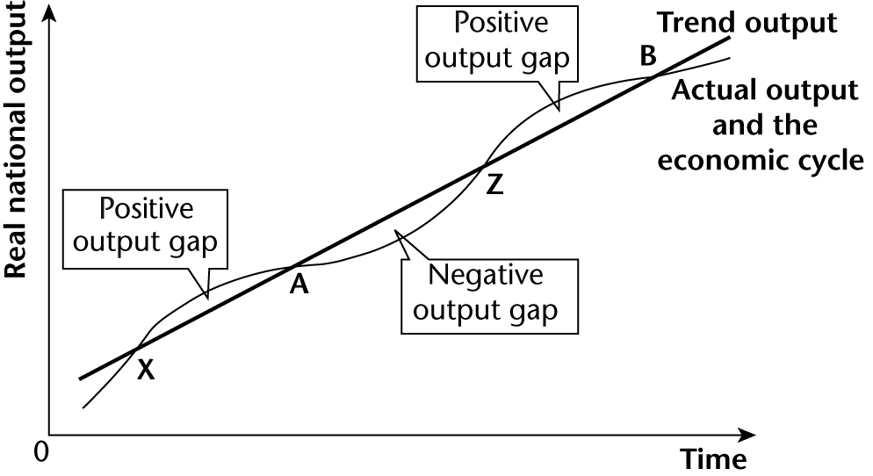
(8 marks)
11 In the UK the technical definition of a recession is two consecutive periods of negative growth.
A downswing in the economic cycle will often lead to a recession but it does not have to. In 2001 there was an economic downswing and the actual rate of growth slowed down but it did not turn negative. The British economy continued to grow in 2002 and 2003 but at a slower rate, below the trend rate of growth. The diagram included in the answer to Question 10 shows how downturns can occur without the economy moving into recession. Economic cycles continued in the years between 1992 and 2008, but without recessions during cyclical downturns. By contrast, the financial crisis, which started in 2007 with the sub-prime crisis, was followed by the deepest recession in the UK since the 1930s. The recession started in Quarter 2 of 2008 and lasted until Quarter 3 of 2009. (6 marks)
12 Inflation is a persistent increase in the average price level whereas deflation is a persistent fall in the average price level. The value of money falls when inflation is taking place and rises when the price level falls in a deflation. (2 marks)
13 The economy’s production possibility frontier illustrates the different production possibilities, for example capital and consumer goods that can be produced with the available stock of factors of production and a given state of technology. The frontier is illustrated in the diagram below:
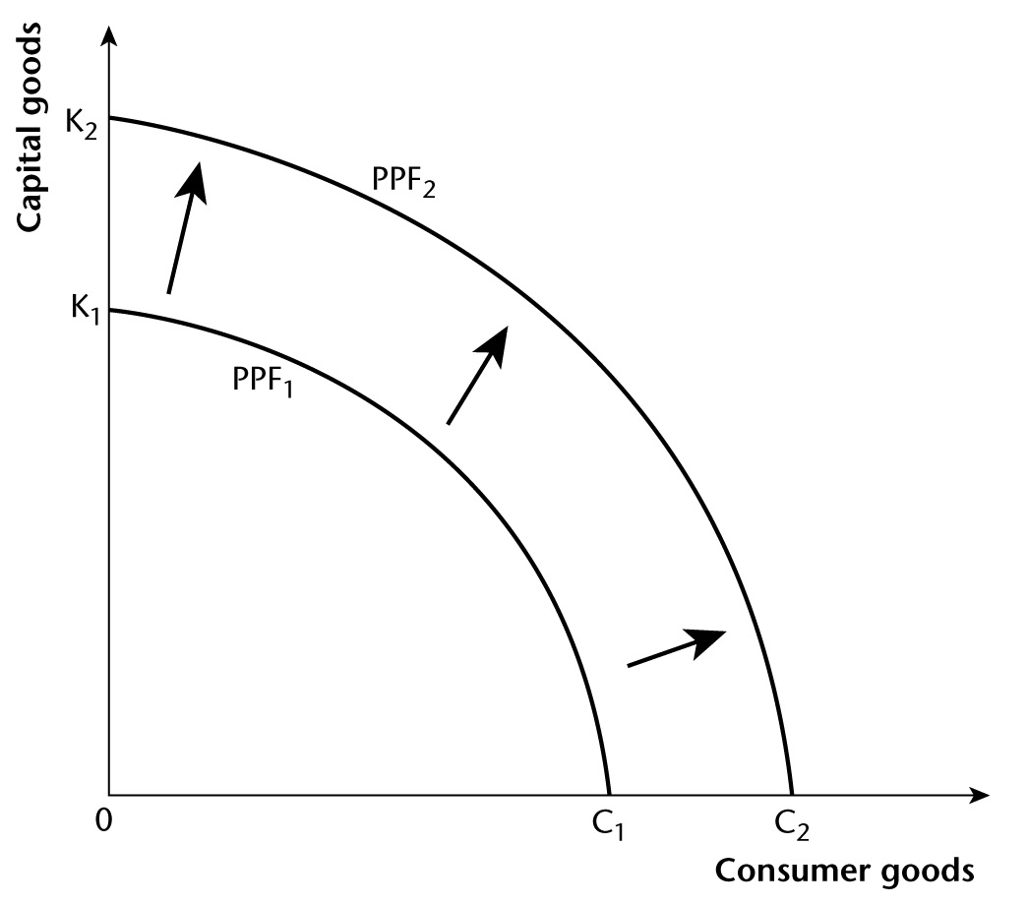
The diagram also shows the difference between short-run economic growth and long-run economic growth. The movement from a point inside the frontier (PPF₁) to a point on the frontier illustrates short-run economic growth (or economic recovery). The outward movement of the frontier from PPF₁ to PPF₂ illustrates long-run economic growth. (2 marks)

Exam-style question (data response) on the economic cycle
01 A recession is defined in the UK as being two consecutive quarters of negative economic growth. (5 marks)
02 The UK economy grew at approximately 1.2% in Quarters 2 and 3 of 2007. These were the fastest rates of growth in the period shown. In contrast the UK economy retracted rapidly in Quarter 4 of 2008, with output falling by roughly 2.3%.
The recession was deep and lasted for five consecutive quarters from Quarter 2 of 2008 until the beginning of Quarter 3 of 2009. This period saw the UK economy contract by almost 7.1%. Overall the UK economy shrank over the total period shown. (8 marks)
03 A recession occurs whenever there is a sharp slowdown in economic activity. As already noted, in the UK this is measured as being two consecutive quarters of negative economic growth. Extract A shows that the UK economy fell into recession in Quarter 2 of 2008 and did not start growing again until Quarter 3 of 2009.
The recession that started in 2008 in the UK was caused by a dramatic decrease in economic activity and a fall in aggregate demand. This can be seen in the above diagram. The diagram shows the AD curve shifting dramatically to the left because one or more of the components of AD have decreased. The components of aggregate demand are: consumption, investment, government spending and net export demand (exports minus imports). Whenever one of the components of aggregate demand decreases, AD declines and economic activity either slows down or the economy falls into recession.
As mentioned, in 2008 the UK suffered a very deep recession shrinking by 7.1%, a contraction described by Extract B as the ‘Great Recession’. This was caused by a collapse in consumption spending by households and the freezing of investment spending by firms. This occurred because of the banking crisis which started in the USA but spread to the UK. This installed fear into firms and households and led to a dramatic reduction in economic activity. As households reduced consumption and firms reduced investment, the level of aggregate demand for goods and services fell and economic growth became negative. (12 marks)
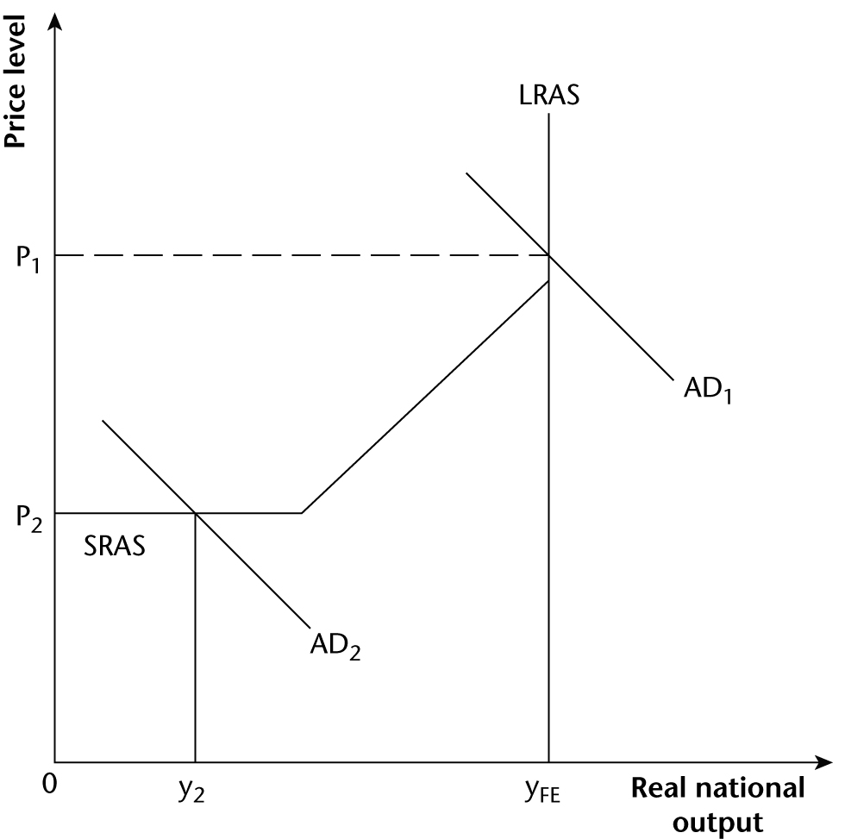
04 A recession is a significant economic downturn and in the UK is defined as two periods of negative economic growth. Recessions invariably result in a government failing to achieve many of its main macroeconomic objectives as low growth or negative growth will lead to higher levels of unemployment, lower average wages, less spending on consumption and a decrease in average household living standards. As Extract C illustrates, the 2008 recession has cost the average UK household £11,000 in income. This is a significant loss and will have a harder impact on poorer households than on the wealthy.
The unemployment caused by a recession can also have significant long-term implications on individuals and families, which can destroy lives. While a short cyclical downturn may only lead to a period of frictional unemployment where workers readjust to the needs of the economy, a prolonged recession can result in long-term unemployment and workless households spanning two or three generations. Workers who remain unemployed for a number of years can find it increasingly difficult to find employment even once the economy has recovered because over time their skills diminish and their experience becomes less relevant. As can be seen in some of the old industrial communities in the north of Britain, this situation has had the undesirable consequence of high levels of long-term unemployment, poverty, a culture of workless households and dependence on welfare benefits. Hence, if a recession creates these conditions it would be dreadful for the long-term performance of the UK.
There can be some benefits brought about by a recession but these are most likely if the recession is a relatively short downturn and not a prolonged depression. Free market economists argue that a recession is a necessary mechanism for correcting market excesses and for punishing bad decision making and inefficiency. As Extract C indicates, recessions result in the ‘survival of the fittest’, where the efficient firms survive and the poorly run go out of business. Companies such as Woolworths went bankrupt because they could not compete with lower cost and more efficient rivals such as Tesco and Amazon.
Recessions can also be seen to be good for the economy as they encourage entrepreneurs to innovate and search out new opportunities. This can take the form of new business ventures. The gastro pub was created in the recession of the early 1990s as sharp-minded businesses sought to tap into the demand for high quality restaurant food at more affordable prices. The early pioneers made huge profits and revolutionised the pub and restaurant industry in the UK. Such innovations can be excellent for the UK economy as firms seek to better serve the wants of consumers and build business models that can be exported to other countries.
Corporate takeovers often increase in a recession and can be good for the economy as new management teams take tough decisions to improve efficiency. In the ‘good years’ managers frequently avoid making unpopular decisions such as mass redundancies. Harsh economic times, however, focus the minds of managers and force them to make tough decisions. This increase in competition is the market’s way of ‘cleansing the economy of inefficiency and making it more able to compete in international markets’ (Extract C).
But while it is true that a recession provides a mechanism for restructuring the economy, partly through successful businesses buying up at rock bottom prices the assets of failing companies, it is also true that many well-run businesses go to the wall in a recession, for no fault of their own. And if one country suffers a recession while rival countries continue to grow, most surviving companies emerge from recession, not ‘fitter and leaner’, but more sickly and less competitive. They emerge having suffered months if not years of very low or zero investment, and therefore poorly equipped in terms of possessing ‘state-of-the-art’ competitive capital equipment. Arguably, on balance, recessions are therefore bad for economies.
(25 marks)
This is a well-constructed answer that displays many of the features necessary to score a high mark. These are: (i) the answer is always addressed at the set question; (ii) each time a new argument is made a new paragraph is started; (iii) the candidate evaluates each argument as it is made; (iv) the concluding paragraph provides a good final overview. However, the answer has been placed at the mid-point of
Level 4 (19/25). This is because the answer lacks explicit application of standard macro-theory; in particular there is no AD/AS analysis.

Topic 2 How the macroeconomy works
1 The Confederation of British Industry (CBI) and the British Chambers of Commerce (BCC).
(2 marks)
2 Factors include:
- government decisions to provide and finance merit goods such as healthcare
- the need for military spending
- the need to spend on road building
- demand-led government spending on unemployment benefits
- decisions made to grant development aid to poor countries (5 marks)
3 Factors include:
- the exchange rate
- the overseas demand for exports
- the price competitiveness of exports
- the quality of exports
- the extent to which similar goods and services are produced in other countries (5 marks)
4 If any of the components of aggregate demand (consumption, investment or net exports) increases, the total level of aggregate demand increases and the AD curve shifts to the right. This is shown on the following diagram:
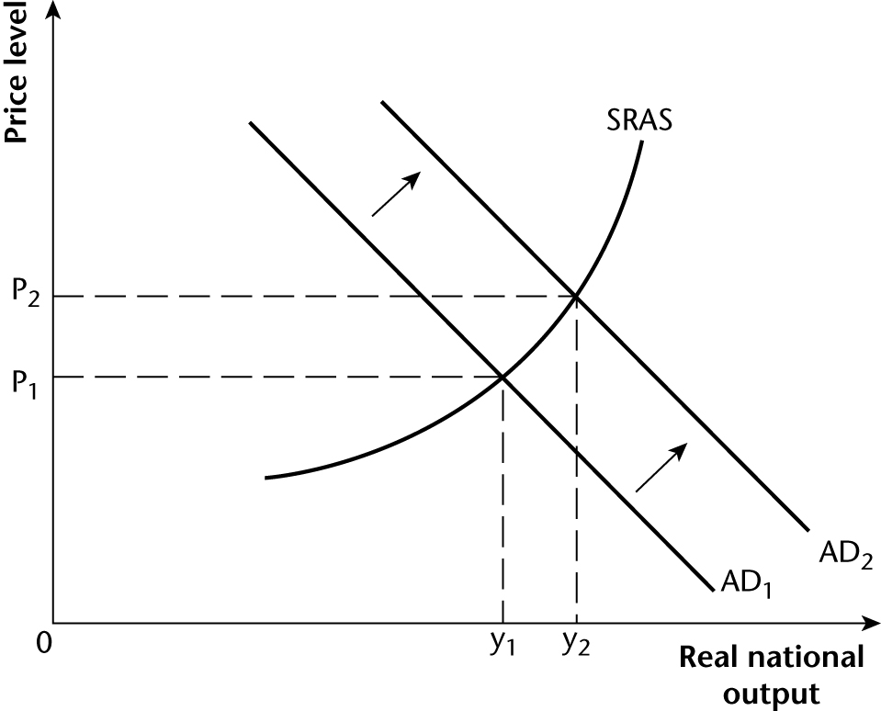
(3 marks)
5 The AD curve shifts to the left. An increase in saving or taxation will mean that households will have less disposable income for consumption and an increase in imports will mean that money is leaking out of the economy as households and firms buy products from foreign companies. (3 marks)
6 Banks perform a function that allows savers to lend indirectly to firms for investment. Households deposit their savings in banks who then lend the funds to firms to finance investment spending on capital goods. Savers benefit by receiving interest on their savings and firms benefit by being able to borrow to invest in capital equipment. (2 marks)
7 If government spending exactly equals tax revenue the government is running a balanced budget. If government spending is greater than tax revenue the government is running a budget deficit. If the government is spending less than tax revenue it is running a budget surplus. (4 marks)
8 The country’s balance of payments on current account is in equilibrium. (2 marks)
9 The upward slope of the SRAS curve is explained by two microeconomic assumptions about the nature of firms. These are the assumptions that: (i) all firms aim to maximise profits; (ii) in the short run, the cost of producing extra units of output increases as firms produce more output. To persuade firms it is in their interest to produce more, the price level must rise. This is because higher prices are required to create the higher sales revenues needed to offset the higher production costs firms incur as they increase output, so that profits do not fall. (4 marks)
10 An AS curve shows the supply of real output at different price levels. The LRAS curve represents the potential capacity of the economy given the availability of factors of production and the state of technology. If aggregate demand increases when the economy is producing at full capacity, real output cannot increase in the short run. The excess aggregate demand that results pulls up the price level. Hence the vertical LRAS curve. (4 marks)
11 (i) SRAS shifts to the left
(ii) SRAS shifts to the right
(iii) LRAS shifts to the right
(iv) LRAS shifts to the right (4 marks)
12 Macroeconomic equilibrium is when total planned aggregate demand is equal to total planned aggregate supply. On a diagram this is shown where the AD curve intersects the SRAS curve.
(4 marks)
13 The annual rate of inflation is measured by the change in the price level over a period of 1 year. If the price level increases, inflation takes place. (2 marks)
14 An increase in government spending injects demand into the economy. An example is a major motorway building scheme which will employ thousands of workers and require billions of pounds of raw materials such as steel, tarmac and cement. This spending should lead to a multiplier effect that exists whenever a change in one variable causes a multiple of stages of change in a second variable. There should be a number of spending stages, each smaller than the previous one because part of the income received is not spent domestically, leaking instead into saving, taxation or spending on imports. In the example of the motorway building scheme, the multiplier should stimulate the economy in two ways. First, the workers directly employed by the government will earn wages that they will then spend in the economy on consumption. Second, the suppliers of raw materials will increase output and employ more workers to meet the increased demand. (6 marks)

Exam-style question (data response) on UK unemployment and inflation
01 Interest rates or the rate of interest is the price of borrowed money. For a saver, the interest rate reflects the cost of borrowing. It is the level of interest that a borrower has to pay to a lender on top of the repayment of a loan. For a lender, the rate of interest is what is earned from lending and forgoing current consumption. (5 marks)
02 Throughout the period shown, the percentage of the unemployed labour force remained higher than the percentage rate of inflation. At the beginning of 2006 approximately 5.5% of the labour force was unemployed but by the beginning of 2011, this had risen to 8%. In contrast the rate of inflation in 2006 was just over 2% but by the end of the period it was over 4.5%.
Over the whole period there was a weak positive correlation between the two variables, except for the year from the third quarter of 2008 to the third quarter of 2009, when unemployment and inflation moved in different directions. Between Quarter 3 of 2008 and the summer of 2009 the percentage of the labour force that was unemployed increased from 5.5% to 8%. In contrast inflation fell and for a period deflation actually set in. The level of inflation in Quarter 3 of 2008 was roughly 4.5% but by the summer of 2009 it was running at −1%. (8 marks)
03
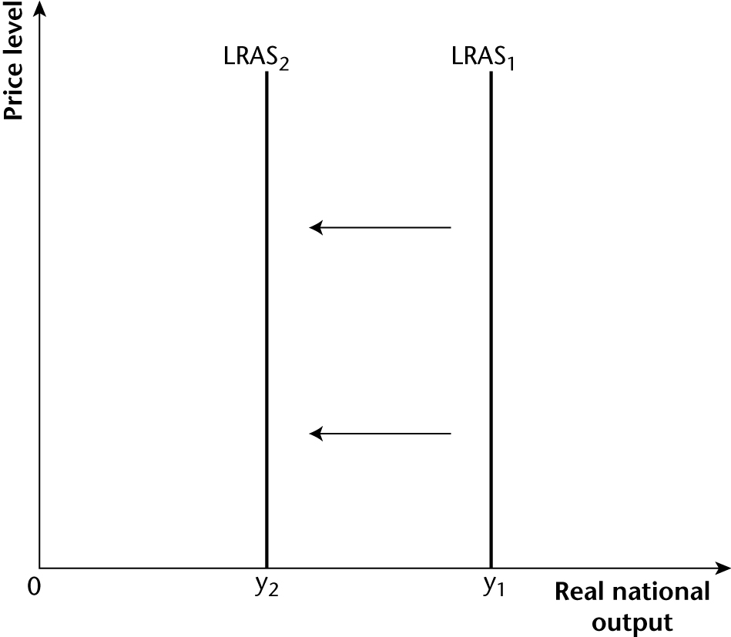
Structural unemployment occurs when an industry or set of industries shut(s) down or relocate(s) to a cheaper labour zone. Firms may close down for a number of reasons, which include lack of demand for their products; the inability to compete with aggressive low-cost international competition; and decisions to move their production plants to other countries to take advantage of cheaper workers and lower average costs. Structural unemployment can also occur because of technical progress, often driven by the move to automated production processes that reduce the need to employ workers. Changes such as these have occurred throughout UK manufacturing, leading to the virtual disappearance of many manufacturing industries such as textile industries and steel manufacturing.
Globalisation has been a long-term driving force in this process as large parts of production and manufacturing have moved to southeast Asia, especially China. However, the 2008 recession looks as if it was the first chapter in a prolonged period of sub-trend growth, which could become a depression. If this does happen, a number of firms will be in danger of closing down due to the long-term lack of demand. This could result in high unemployment as sectors of the economy close down and a raft of ‘jobs for certain skills and industries’ are lost (Extract B). (12 marks)
04 The base interest rate in the UK (Bank Rate) is set by the Monetary Policy Committee (MPC) of the Bank of England. The remit of the MPC is to set Bank Rate in order to hit the 2% inflation target set by the chancellor of the exchequer. The MPC’s primary objective is to hit the inflation target in the long run but also to consider secondary issues such as economic growth and the level of unemployment in the short run.
Since 2009, the UK inflation rate (measured by changes in the CPI rather than changes in the RPI) has been well above the 2% target rate. This suggests that if monetary policy was solely aiming to reduce inflation, the MPC should have increased bank rate. In the outcome, the opposite has been the case. From 2009 until at least 2012, Bank Rate has been set at a historic low of 0.5% in order to help prevent the UK economy falling into a deep and prolonged recession.
As Extract B explains, very low interest rates should in theory help the UK economy pull out of a recession by ‘eventually stimulating demand and encouraging businesses to start hiring again’. The economic reasoning is that low interest rates will make borrowing more attractive and encourage spending. Households will save less, borrow more and overall consumption expenditure will increase. Given that consumption is the most important component of aggregate demand and accounts for nearly 70% of AD, low interest rates should have led to a significant injection of spending into the economy. Likewise, firms, taking advantage of the cheap cost of borrowing by taking out business loans to finance investment spending, should have promoted a further increase in aggregate demand.
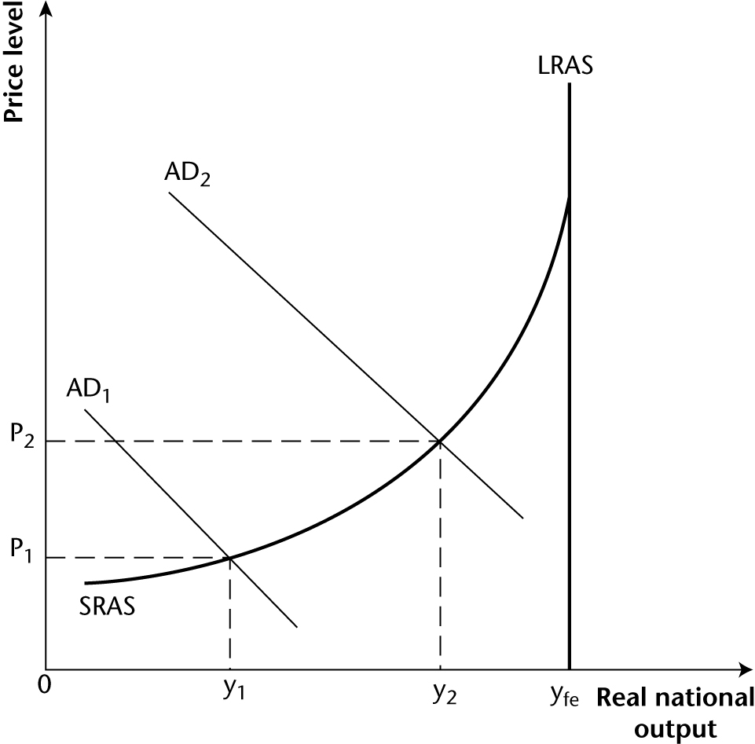
The increase in aggregate demand (from AD₁ to AD₂) created by low interest rates should result in increased production (from y₁ to y₂), which should help to prevent a significant increase in unemployment. Moreover, the increase in investment spending should also have the long-term benefit of increasing the national capital infrastructure which should also help to create a long-term increase in employment.
The major drawback with this low interest rate policy is twofold. First, it is reliant on households and firms actually borrowing on cheap credit and increasing their spending. Unfortunately it appears that many households and firms have not increased spending but taken the low interest rate opportunity to pay off their debts. This is not necessarily a bad outcome but it does limit the extent to which low interest rates help to check increase in the level of unemployment.
Second, as Extract C makes clear, low interest rates are having a very bad effect on groups living off savings, such as pensioners. The problem is that this section of society relies on the interest from their savings for a significant amount of their monthly income. However, given that ‘the average instant access saving account offers interest of just 0.3%’ (Extract C) and inflation has been as high as 5% (Extract A), pensioners have experienced a dramatic fall in their incomes and living standards.
The low interest rate policy has made many sections of society poorer and failed to prevent unemployment from rising. This does not mean that the policy has been a complete failure. If interest rates had been higher it may have benefited savers slightly but it might have made the recession even deeper and resulted in an even larger increase in unemployment as over-indebted households and firms would have been unable to keep up with the interest repayments on their debt. Many economists take the view that low interest rates on their own are not enough to ensure that the economy ‘spends itself out of recession’. Hence the introduction of another form of monetary policy known as quantitative easing, which is akin to printing more money for the general public to spend. Some economists go even further and argue that monetary policy of whatever form on its own cannot lead to recovery from recession. Other policy instruments, particularly fiscal policy, must also be used. In the words of J. M. Keynes, the weakness of relying on monetary policy to stimulate the economy is that it is like ‘pushing on a piece of string’. (25 marks)
This is an excellent answer that crosses the boundary between Level 4 and Level 5. The key characteristics of a Level 4 answer are ‘good analysis but limited evaluation’ or ‘reasonable analysis and reasonable evaluation’. By contrast, Level 5 requires ‘good analysis and good evaluation’, together with a good and clear final judgement. The candidate evaluates at all stages of the answer and scores full marks (25/25).
Topic 3 Economic performance
1 (i) This is when there are sufficient jobs available for everyone seeking work. It occurs at the market clearing real wage rate in the economy’s aggregate labour market at which the number of people seeking work exactly equals the number of workers that firms and other producers wish to employ.
(1 mark)
(ii) Short-run economic growth is an increase in real output resulting from using spare capacity and labour in the economy. Long-run economic growth is an increase in the potential real output the economy can produce. (1 mark)
(iii) Inflation is a continuing or persistent tendency for the price level to rise. (1 mark)
2 The conflict between achieving economic growth and controlling inflation. (1 mark)
3 As an economy grows, businesses become more willing to invest in state-of-the-art capital to improve the quality of their products and/or reduce costs of production. High-quality investment will enhance the efficiency of a firm, lower average costs, increase productive capacity and improve the quality of the good or service. This process should result in a more competitive economy, both internally within the economy and internationally. (3 marks)
4 The answer to Topic 1 Question 13 illustrates short-term economic growth in terms of a movement from a point inside the economy’s production possibility frontier to a point on the frontier. The diagram below (which develops the diagram included in the answer to Topic 2 Question 4) shows short-term economic growth moving the economy from a macroeconomic equilibrium at point X to a new macroeconomic equilibrium at point Z:
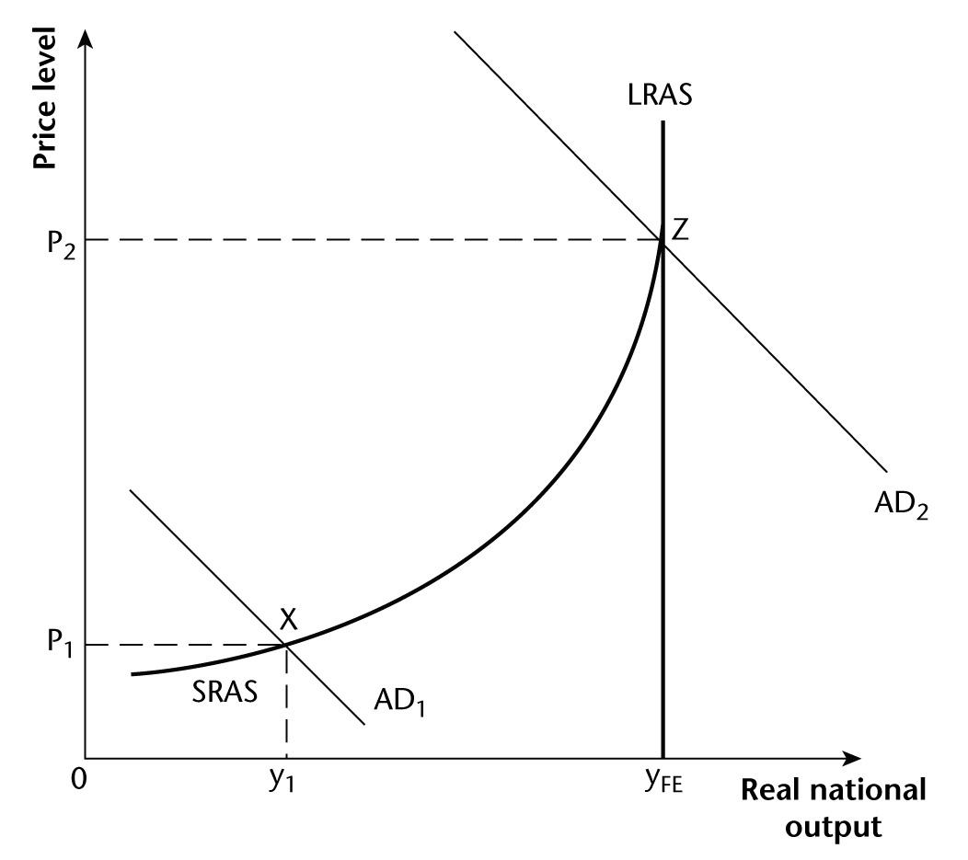
The increase in real output from y₁ to the full employment level of output y_{FE} shows short-run economic growth taking place. (3 marks)
5 Whereas the AD/AS diagram in the answer to Question 4 shows short-run economic growth taking place, the rightward movement in the LRAS curve in the diagram on the next page illustrates long-run economic growth. (Long-run economic growth is also shown by the outward movement of the economy’s production possibility frontier in the diagram in the answer to Topic 1 Question 13.)
(2 marks)
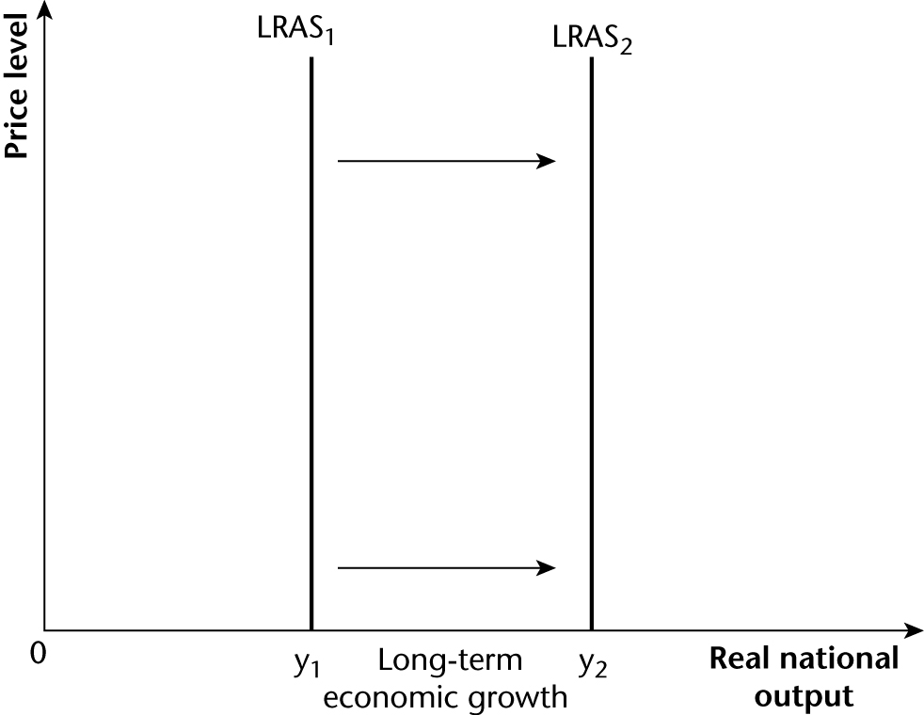
6 The retail prices index (RPI). (1 mark)
7 The CPI is a price index that tracks price changes in a basket of goods and services. The basket is designed to reflect the consumption habits of the ‘average’ household. Each month economists monitor the price changes of thousands of goods and services from stores and other retail sites across the UK. The purpose is to record the average price level facing the average household. (4 marks)
8 Demand-pull inflation is illustrated in the left-hand panel of Figure 2. Excess demand results in demand-pull inflation. This occurs as households have higher levels of disposable income and choose to increase consumption. As consumption is a component of AD this means that the AD curves shifts to the right. This results in an increase in demand for goods and services, which is met in part by an increase in real GDP (provided there is spare capacity in the economy) and in part by a higher price level. The extent to which real output and the price level increase depends on the shape and slope of the SRAS curve, which in turn depends on assumptions about the initial state of the economy and about how the economy reacts to an increase in aggregate demand. (4 marks)
9 Cost-push inflation is illustrated in the right-hand panel of Figure 2. Cost-push inflation is driven by conditions in the supply-side changing and increasing costs. The capacity of the economy remains fixed but variables such as the cost of raw materials, wages costs, and/or taxation may increase, pushing up the costs of production for businesses. The SRAS curve shifts to the left because firms have to increase prices as they try to maintain profit margins in response to rising costs. (4 marks)
10 This is inevitable because the claimant count only measures those actively looking for work and claiming job seeker’s allowance, whereas the LFS measures those actively looking for work but not claiming benefits. The LFS is a more general quarterly survey that seeks to provide a detailed picture of the different types of employment, unemployment and the economically inactive across the UK.
(4 marks)
11 Frictional unemployment is voluntary unemployment and will exist in all economies as workers search and apply for new jobs. The length of this form of unemployment will be determined by the availability of employment that matches a job seeker’s aspirations, the level of welfare benefits available, and the savings an unemployed worker can draw upon while he or she is searching for the right job.
Structural unemployment is a long-term cause of unemployment and occurs when an industry or sector of the economy either disappears or relocates to another country. This can happen due to technological change which transforms the production methods of an industry, replacing workers with automated machines. It has also occurred in the UK as many manufacturing factories have relocated to cheaper labour zones, for example China, where workers will accept wages that are less than 10% of those of their British counterparts. (6 marks)
12 The calendar bought for my sister from the French Amazon website will be counted as an import into the UK because you will be buying a product from France and paying for it from Britain. The calendar that you send to your brother will technically be a British export because it is made in the UK, sent to the USA and payment will be sent from the USA to the UK. However, this payment will not show up in the Office for National Statistics official data. (4 marks)
13 Income flows are money flows received by households or firms in a country on assets that they own in another country. For example, if a British person owns a property in Paris that is rented to a Frenchman, the rent received will be counted as a positive income flow into the UK.
Transfer flows include inter-government payments. An example is the UK government’s annual contribution to help fund the European Union. (4 marks)

Exam-style question (data response) on the UK trade gap
01 Economic growth is the long-term expansion of the productive potential of the economy. Growth is often measured over a year by a percentage change in GDP. Short-term growth occurs when idle productive capacity is brought into production. (5 marks)
02 Throughout the period there was a deficit in the balance of trade in goods and services. At the beginning of 2007 the deficit was approximately £15 billion. This narrowed to about £5 billion towards the end of 2008 and by the end of the period in 2011 it remained at just over £5 billion.
Both imported and exported goods and services fell dramatically in the second half of 2008 and did not begin to recover until the middle of 2009. Imports fell from £118 billion to £100 billion and exports fell from £108 billion to £94 billion. (8 marks)
03
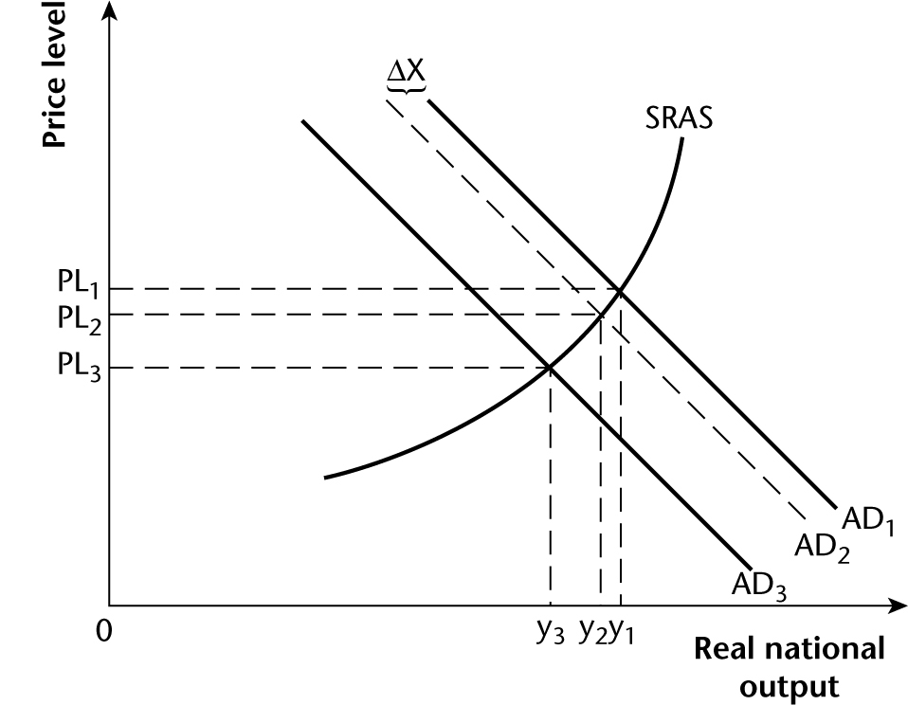
A negative multiplier effect is when an initial reduction in spending leads to a larger eventual fall in aggregate spending and national output or income, via a number of smaller reductions of spending throughout the economy.
Exports are goods and services produced in the UK and sold to firms and households in other countries. The sale of exports leads to an injection of spending into the UK economy. Exports are a component of aggregate demand. The formula for aggregate demand is:
AD = C + I + G + (X – M)
A decrease in demand for exports will result in an initial decrease in aggregate demand, which can be seen on the diagram when AD₁ shifts to AD₂. Fewer goods and services are sold hence GDP will decrease from Y₁ to Y₂.
There will, however, then be a number of knock-on effects. As demand for UK exports falls firms will start to cut back on production. This will mean that they order fewer raw materials from their suppliers, cut back on overtime hours, freeze wages and in some cases make workers redundant. This will have an effect on consumption spending. The firms that experience less demand will cut back on production and workers will have less disposable income and will therefore reduce consumption expenditure. The consumption component of AD will then decrease and the AD curve will shift further to the left, from AD₂ to AD₃. National income falls to Y₃. (12 marks)
04 The management of aggregate demand is very important for the short-term management of the UK economy but if the UK government wants to reduce the trade gap in the long run it needs to implement supply-side reforms in order to make UK exports competitive on international markets and attractive to foreign consumers.
The persistent trade gap shown in Extract A has developed over time because UK households have a high demand for foreign imports but UK firms simply do not produce enough goods and services that are competitive on world markets. Indeed, some goods such as dishwashers are not produced at all in the UK so British consumers have to buy imported goods. This is a long-term phenomenon that can be traced back at least to the early 1980s.
Demand-side policies could help to reduce the size of the deficit in two ways. First, a recovery in demand in the eurozone economies where UK firms sell most of their exports should help, but this is unlikely given the scale of the debt crisis facing these economies. Second, the UK government could embark on a deflationary policy aimed at reducing UK households’ expenditure on imports. It would not be possible for the government to impose tariffs on imports because of treaty obligations and its membership of the European Union and World Trade Organization. This would mean that the most effective method of reducing the trade gap would be to reduce levels of household disposable income by increasing taxation and interest rates so that households have less money for expenditure on imports. This would be an unpopular policy that would result in lower living standards. Effectively, the government sacrifices internal or domestic policy objectives such as full employment and economic growth in order to try to achieve an external policy objective.
Therefore the best way of actually reducing the trade gap would be to make UK goods and services more attractive to both British and foreign consumers. This requires successful supply-side reforms undertaken over many years. These would not be easy to achieve, but they would help to stimulate the export-led recovery mentioned in both Extracts B and C.
The supply-side reforms would need to encourage British firms to produce high-quality goods and services that the fast-growing emerging markets would want to buy. As Extract C makes clear, this is where a successful economic future lies. Unfortunately, it will be very difficult to make this policy successful because at present UK firms sell more exports to the Republic of Ireland than to Brazil, Russia, India and China (the BRIC countries) combined. Hence, the UK government would need to really encourage and promote UK industries and help them to make links in the emerging markets.
This supply-side growth will require British firms to invest heavily in both capital goods and people in order to make the goods and services that would compete on international markets. Demand-side policies in the UK can be used to reduce the trade gap by cutting expenditure. Supply-side policies are easy to recommend but difficult to implement but they will tackle the long-term reasons for the UK’s deficit.
To conclude, however, it is necessary to focus on the word ‘solely’ in the question. It implies that demand-side and supply-side policies and reforms are alternatives for each other and that to choose one has to mean not using the other. But if the government relies solely on supply-side reforms, there is a danger that insufficient aggregate demand will be generated to absorb the extra output the reforms produce. It is unwise to rely on exports and on the domestic private sector automatically or ‘naturally’ creating the extra demand that is required. The government must make sure that demand-side policies, particularly monetary policy, are used to ensure that demand matches supply. Also, it is important to repeat that supply-side reforms deliver increased output and competitiveness in the long run but not necessarily in the short run. In the short run, demand-side policies, particularly those that can reduce the exchange rate, may be required to promote international competitiveness. (25 marks)
This is an excellent Level 5 answer that earns all 25 of the available marks. The concluding paragraph is particularly impressive. It is always a good idea to look for words in the question such as ‘must’, ‘always’, ‘inevitably’, ‘never’, or in this case ‘solely’. When words of this type appear, an answer that agrees (or disagrees) 100% with the central assertion in the question is unlikely to score highly. By contrast, an answer which argues that ‘it all depends on circumstances’ (or on the assumptions being made) is what the question is looking for.

Topic 4 Macroeconomic policy
1 A budget deficit is when government spending is greater than tax revenues and the government needs to borrow money to finance the shortfall. A budget surplus is when government tax revenues are greater than its spending. This enables the government to pay off a part of the national debt. A balanced budget is when government spending is equal to tax revenues. (3 marks)
2 In recent years the UK government has been running very large budget deficits. There has not been a budget surplus since the late 1990s. (1 mark)
3 (i) Sovereign debt is simply government debt. It is the accumulation of successive budget deficits over time. (1 mark)
(ii) Until quite recently, when the national government of a developed economy ran budget deficits, it financed the deficits by borrowing internally, within the country. Nowadays, governments borrow largely on international financial markets. This, together with the massive increase in the size of national debts and budget deficits, has led to the emergence of huge sovereign debts. Sovereign debt has become a major problem in recent years because serious doubts have emerged about the ability of countries to ever repay the debts that they have accumulated. Countries such as Greece have a national debt of approximately 150% of GDP. Furthermore, the debt is set to increase as the 2011 Greek budget deficit is running at close to 10% of GDP. This huge borrowing has alarmed markets which fear that if they lend money to the Greek government it will never be paid back. As a result heavily indebted governments simply do not have any money to spend on a fiscal stimulus because they already have massive debts and the markets are calling for austerity budgets that radically cut government spending to significantly reduce the size of budget deficits.
In 2011 the UK’s budget deficit was forecast to be approximately 9% of GDP and the national debt was predicted to peak at just over 78% of GDP. (6 marks)
4 Supply-side economists believe philosophically that the government’s role in the economy is that of an enabler rather than a provider. The government should aim to create competitive and efficient markets, in which the private sector will create more wealth. The government should not attempt directly to manage the economy, though less extreme supply-siders accept that monetary policy can be used for this purpose. However, taxation should not be used to manage aggregate demand. Supply-side economists recognise that taxation is necessary to raise funds to provide essential public services; however, they believe that if taxation levels are set too high they actually hamper economic growth. This is because businesses and entrepreneurs are motivated by the profit incentive. High taxation reduces real wages and creates a disincentive to work long hours and to take business risks. Low taxation creates incentives, rewards work and innovation, and allows successful firms to make larger profits which they can then use for investment. (6 marks)
5 As can be seen in the diagram on the next page, the main effect of an increase in the Bank Rate (the rate of interest at which the Bank of England lends to the banking system) will be to reduce AD and bring down the price level. This will happen because an increase in Bank Rate will lead to high street banks increasing the rates of interest they charge borrowers on their loans. The most significant group who will be affected by an interest rate rise will be householders with mortgage debts. This group will have to pay higher monthly interest repayments and will therefore have less money available for consumption. They may also fear another future rate increase and may decide to save more of their disposable income because of the uncertainties in the future. As a result, household consumption, which is the most important component of AD, will decrease. This will cause AD to fall and the AD curve will shift to the left from AD₁ to AD₂. According to the diagram, the price level will then fall from P₁ to P₂. (6 marks)
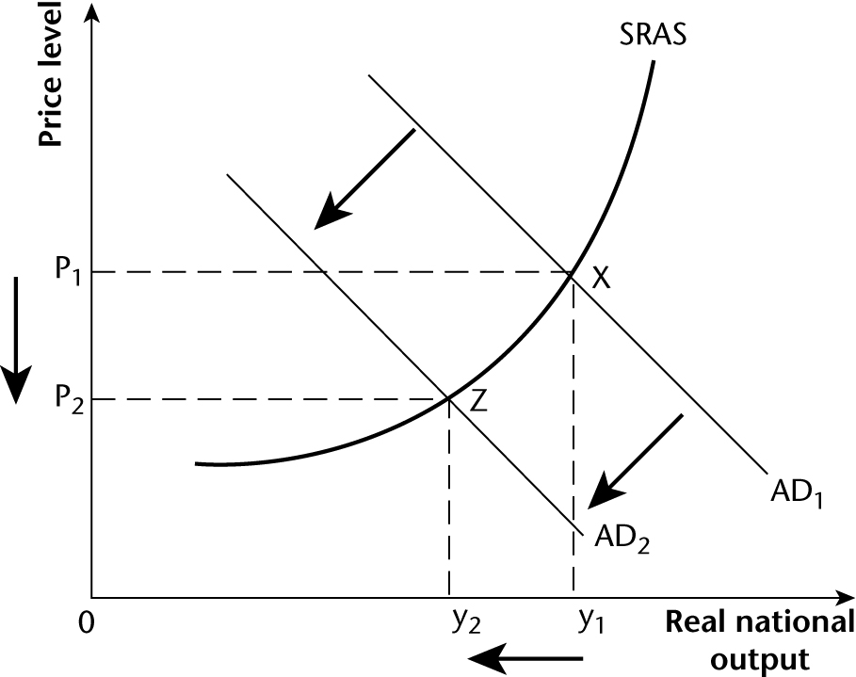
6 Cost-push inflation is a dangerous form of inflation that hinders economic growth as it pushes up the price level. An increase in interest rates could cause more harm than good because it is a solution to demand-pull inflation and not cost-push inflation. Rising energy and food prices are caused primarily by events outside the domestic economy.
In 2010 and 2011 inflationary pressures in the UK were driven by high demand for energy and food in the emerging markets. Although the North Atlantic economies were stuck in a deep recession, China and India were still seeing GDP growth at almost 9% and 7% respectively. These two countries have populations of over 1 billion people and they are demanding commodities such as oil and food in huge quantities. Higher interest rates are a good way of tackling demand-pull inflation but they will not prevent commodity prices from increasing on the world markets.
Increasing domestic interest rates depresses aggregate demand in the economy. Although this will depress demand for food and energy, which might ameliorate price increases for these goods, its main effect will be to punish or deflate the domestic economy.
Also, higher interest rates may increase the value of the exchange rate, which could help to check imported inflation. Since 2008 the value of Sterling has decreased by roughly 25% against the US dollar. This has led to an increase in the cost of imported goods, many of which are measured in the CPI and RPI price indexes. An increase in interest rates may help to increase the value of Sterling by attracting ‘hot-money’ into the currency, but it will harm AD by increasing the mortgage costs of many households. This could make the economic situation worse and dramatically hinder economic growth. (10 marks)
7 Quantitative easing is an unorthodox use of monetary policy in an attempt to inject liquidity into the financial system and help banks to lend money to other banks, businesses and households. Quantitative easing is the name given to the process of a central bank electronically increasing the money supply by directly buying less-liquid assets in the market place. Since 2009, the Bank of England has been creating over £300 billion, which it has used to buy assets from banks and financial institutions. These assets have mostly been UK government bonds, although equities, corporate bonds and even houses can be bought. The purpose has been to inject cash into the markets, to create demand for assets and to bring down corporate borrowing costs. (5 marks)
8 QE1 is the nickname given to the first period of quantitative easing, which in the UK lasted from March to December 2009, creating £200 billion of ‘new money’. In October 2011 a second bout of quantitative easing (nicknamed QE2) was announced, which would create a further £75 billion of new money. QE3 followed in February 2012.
It is difficult to judge the success of QE on the UK economy. For supporters of the policy in Britain, such as Sir Mervyn King, the policy has helped prevent the UK economy falling into a deflationary spiral and a deep depression. QE has been successful at injecting liquidity into the economy and encouraging spending in financial markets. Supporters believe that QE stimulates the economy in a way that low interest rates cannot. If QE helped the UK avoid a deep depression and a debt crisis then it was successful.
Critics of QE believe that it was responsible for much of the imported cost-push inflation that has affected the UK economy. Since 2009 the central banks in the USA, Japan and the UK have all engaged in large QE programmes. This has injected huge quantities of cash into the global financial system and led to a situation that has become known as a currency war. As each central bank creates new money it effectively devalues its currency by causing its exchange rate to fall, in the hope of giving its export industries a competitive advantage in world markets. One problem has been that central banks bought illiquid assets from banks which trade on international markets, and the new money has been invested by the banks in the fast-growing emerging markets of China and India where returns are seen to be higher. This has fuelled economic activity in these markets but also accelerated the problem of demand-pull inflation as more money is chasing the same number of resources. This has driven inflationary pressures in commodity markets, which is causing imported cost-push inflation to seep into the UK when high-cost commodities are imported.
QE operates through the central bank (in the UK, the Bank of England) using newly-created money to buy relatively illiquid financial assets such as government bonds from the private enterprise banking system. In the UK, the Bank of England hoped the banks would then lend the money to domestic firms and households to boost aggregate demand. In fact, much of the new money was not lent to British firms and households, being used instead to repair the banks’ balance sheets which had been ravaged by the financial crisis. Also, as noted above, the new money was lent overseas.
In summary, QE may have helped stimulate the UK and save it from a deep depression or the need for a debt bailout but it may also be partly responsible for the imported inflation that has seen the Bank of England consistently miss the inflation target in recent years. (10 marks)
9 Improving the productivity of both capital and labour. This could be achieved through government grants and tax breaks given to firms to encourage investment in new capital equipment. The government could cut corporation tax, which would boost company profits and enable firms to have greater funds available for investment. Government could help finance and provide education and training schemes to allow workers to attain higher skills. Income tax could be cut which would effectively increase wage levels and create greater motivation to work.
Increasing occupational and geographical mobility of labour in order to reduce unemployment. This could be achieved through retraining and education schemes, which are probably the most important policy schemes for overcoming the problem of occupational unemployment. Unemployed workers may have high levels of skill that are non-transferable. For example, many workers who have been made unemployed from engineering firms such as BAE systems are highly qualified but their specialist skills are only used by a small number of firms.
Geographical mobility is a much more difficult problem. The simple answer is to say that government should build more affordable houses to buy and rent in areas of high employment and encourage the unemployed to move there. This has two major flaws. First, unemployed workers, especially those over the age of 35, are often unwilling to relocate hundreds of miles away from their family and social networks. Second, and more importantly, in the high employment areas of London and the southeast of England there is already a housing shortage and demand for housing already far exceeds the available supply. In order for the government to resolve this problem it would have to remove many of the planning laws that are currently in place to protect the ‘green belt’ and conserve the countryside.
There is, however, another policy that has been tried in many areas such as Middlesbrough, which is to encourage new firms to relocate in areas of high unemployment by offering grants and tax breaks. So far this scheme has had mixed fortunes in attracting new firms and encouraging them to employ the long-term unemployed because the workers often lack the necessary skills and experience that firms are looking for. (6 marks)

Exam-style question (data response) on UK government finances
01 A budget deficit is a situation when in a given year a government’s spending is greater than its tax revenues. When this occurs a government needs to borrow money to make up for the shortfall. (5 marks)
02 For most of the period shown the UK government ran budget deficits. The UK government ran a budget surplus in only 6 out of the 25 years in the period shown. Two small surpluses were run between 1988 and 1991, and four more surpluses were run between 1998 and 2002. The peak surplus was in 2000–01 at 2% of GDP.
In all other years budget deficits were run. The peak (actual) deficit was in 1993–94 at around 9% of GDP, while the peak (forecast) deficit was predicted to be around 11.5% of GDP in 2009–10. (8 marks)
03 A structural deficit is when a government runs a persistent deficit throughout the economic cycle rather than solely in a cyclical downturn. As Extract B says, the UK was running a structural deficit in 2007 because it had a deficit that was ‘not caused by the effect of a recession’. Indeed in 2007 the UK economy was in the boom stage of the economic cycle, yet it was still running a budget deficit of 3.1% of GDP (Extract B).
As its name implies, a structural deficit relates to the structure of the economy. When the economy’s structure changes, this affects government spending and tax revenues. For example, an ageing population increases government spending on the state pension and on the NHS (because people in their eighties and nineties require more health service provision). The break-up of the nuclear family, which leads to more single parents, increases government spending on welfare benefits and reduces tax revenues if single parents are unable to work because they are looking after their children. The deindustrialisation of the British economy and globalisation have eroded the UK tax base. Many manufacturing companies have shrunk in size while others have moved abroad, paying taxes to overseas governments rather than to the UK government. These and other factors have contributed and are continuing to contribute to the growth of the structural budget deficit. (12 marks)
04 Macroeconomic performance can be judged in terms of the success or failure of achieving sustained low unemployment, sustained economic growth at an acceptable rate of growth, an acceptable rate of inflation, and sustained competitiveness of the country’s industries in international markets. The policy of fiscal restraint or fiscal consolidation is one where the government seeks to reduce the size of the budget deficit, eliminate the structural deficit and keep the national debt at a sustainable level. It is often called an austerity programme because the deficit reduction agenda reduces people’s real incomes and spending power, and results in low growth, high unemployment and a decrease in average living standards.
The current UK Chancellor, George Osborne, is pursing the policy of fiscal restraint because he believes that the size of the budget deficit is too big. Osborne argues that high deficits will inevitably result in a dramatic increase in the national debt, as evidenced from the examples of Ireland and Greece. Once a nation goes down this path, it can become bankrupt because international financial markets refuse to lend its government any further funds. If this happens, then the government will be forced to ask the International Monetary Fund (IMF) for a bailout. Past evidence is that when the IMF provides loans to countries, the IMF requires countries to impose highly deflationary fiscal and monetary policies which result in a failure for the government to meet most of its macroeconomic objectives.
The policy of fiscal restraint centres on a combination of tax increases and the cutting of government spending. Already, increased taxation has reduced consumption spending significantly. The increase in the indirect tax VAT to 20% has reduced consumption and increased the average price level. This caused cost-push inflation, which has an adverse effect on macroeconomic performance. Increased income taxes have predominantly hit the top earners but the benefit cuts announced will hit middle and lower income groups. The effect of these policies will be to reduce levels of disposable income, which will invariably lead to a reduction in consumption spending. This will harm economic growth.
Aggregate demand (AD) will also suffer in the economy as government expenditure is cut in order to reduce the size of the budget deficit. George Osborne has announced plans to cut government spending by £81 billion by 2015. Government spending is an important component of AD and this will affect growth significantly. This will also mean that a number of government services will disappear and many citizens who are reliant on the state will experience a significant fall in their standard of living.
The Chancellor is hoping that private sector firms will begin to recover from the recession and will start to grow and provide alternative employment. However, even if this does happen it appears unlikely to counterbalance the huge increase in unemployment caused by the massive cutbacks in government spending.
The policy of fiscal restraint will result in high unemployment, low or negative growth and deterioration in living standards for the average household. The alternative policy is to continue to run a high budget deficit since this will inject spending into the circular flow of income. This will trigger a positive multiplier effect, causing national income to increase by more than the increase in the budget deficit, inducing a higher rate of recovery from recession, which in turn will eventually reduce the size of the cyclical deficit — but not the structural deficit.
However, the emergence of the sovereign debt problem, caused by international financial markets refusing to finance growing government budget deficits, reduces the government’s scope for an expansionary fiscal policy, even if George Osborne believed that such a policy could be effective. International financial markets are simply not prepared to lend to governments to finance growing budget deficits. Partly because of this, the government argues that it has no choice: there simply is not an alternative to fiscal restraint. It hopes that fiscal restraint will free resources for the private sector to use and that private sector growth will offset the deflationary impact of fiscal restraint. As yet, early in 2012, there is little or no evidence of this happening. This means that fiscal restraint has had an adverse effect on UK macroeconomic performance. (25 marks)
The skills displayed of knowledge, application and evaluation mean that the answer reaches Level 4 (19/25 marks). However, the lack of diagrams means that analysis is on the thin side.

